**System Design Specification Document (SDS)**



**Project 4 - E-commerce System for Marginalized Communities**





The purpose of this document is to describe how the user’s requirements would be satisfied whilst keeping in mind the software/hardware platform on which the system is to be implemented. The document provides detailed graphical models and a narrative definition of the system to be implemented given the user’s specifications.

**Team members:**

Ronald Chinku 10c4865

Giovanna Contu 10c1399

Dusan Gnjatic 10g0351

Ntsane Kolisang 97k5191

Tsungai Makoni 10m3716

Abram Rankapole 09r0881

**Supervised by:**

Ed De La Rey

**Revision History**

|  |  |  |
| --- | --- | --- |
| **Version and Date** | **Description** | **Author** |
| Version 0.1 (17 May 2013) | Initial Version: Theory | Abram, Ntsane, Ronald, Giovanna & Dusan |
| Version 0.2 (21 May 2013) | Second Version: Theory and Diagrams | Giovanna, Ntsane, Tsungai, Ronald & Abram |
| Version 0.3 (23 May 2013) | Initial changes | Abram, Ntsane & Giovanna |
| Version 0.4 (1 August 2013) | Working on any changes still to be made | Abram & Giovanna |
| Version 0.5 (7 August 2013) | Additional diagrams for iteration | Tsungai, Ronald & Dusan |
| Version 0.6 (9 August 2013) | Finalisation of document thus far | Abram, Ntsane & Giovanna |
| Version 0.7 (13 August 2013) | Compilation of information | Abram, Dusan, Ntsane & Giovanna |
| Version 0.8 (15 August 2013) | Additional changes | Abram, Tsungai & Giovanna |
| Version 0.9 (16 August 2013) | Finalization of document | Abram, Ronald, Ntsane & Tsungai |
| Version 1.0 (06 September 2013) | Working on the necessary changes which needed to be made | Abram, Ntsane & Giovanna |
| Version 1.1 (11 September 2013) | Addition of diagrams for this iteration and changing the content | Abram |
| Version 1.2(11 September 2013) | Edited and Revised Section 1.2, 3.1.1 to 3.1.8. | Ntsane |
| Version 1.3 (26 October 2013) | Edited and changed sequence diagrams and fixed class diagram. | Abram |

Table of Contents

List of Figures 5

List of Tables 6

1. Document Overview 8

1.1. Purpose and Scope 8

1.2. Technical Overview 8

2. Methodology Used 10

3. User Interface Design 11

3.1. General Considerations and Heuristic Considerations 11

3.2. Narrative detailed specifications 13

3.2.1. Generic Frameset 15

3.2.2. Generic Tables 16

3.2.3. Generic Forms 17

3.2.4. Generic Report 19

3.2.5. Application Screens Specification Definitions 20

3.3. Window Pages: Storyboards 54

3.3.1. Iteration 1: Use Case 1 User Login 54

3.3.2. Iteration 2: Use Case 3: Add Product Details 55

3.3.3. Iteration 2: Use Case 4 and 5 View Product Details 56

3.3.4. Iteration 2: Use Case 2 Edit Artist Details 57

3.3.5. Iteration 3: Use Case 6 View Sales 58

3.3.6. Iteration 3: Use Case 8 Synchronisation 59

3.3.7. Iteration 4: Sample Language Localisation Screen 60

3.4. Graphical Application Map – Level Views 64

3.4.1. Permanent Indicators: 65

3.4.2. User Guidance 65

3.4.3. Summary Reports 65

3.5. Use Case/Interface Dependence Matrix 66

3.6. User Interface Dialogues 67

3.6.1. Screen Navigation 67

3.6.2. Screen Layout 67

3.7. Testing and Usability 67

3.7.1. Functional Testing 67

3.7.2. Usability Testing 68

4. Database Design 68

4.1. Target Database Selection 68

4.2. Relational Database Model Diagram 70

4.3. Relationship Model 70

4.4. Database Size 72

5. Security and Control Design 76

5.1. Threats 76

5.1.1. The following are the factors that we think will pose major threats to the system: 76

5.1.2. Preventative Strategies that we have suggested are: 76

5.2. Audit Trails 76

5.3. System access and Control 76

5.4. Back-up and recovery facilities 77

6. Environment Design Specifications 78

6.1. Architectural Layer Design 78

6.2. Hardware Platform 80

6.3. Operating System Platforms 81

6.4. Third Party Software Consideration 81

6.5. Network Platforms 81

6.6. Help Design 81

7. Iteration 3: Function and Program Design 83

7.1. Design-level Use Case Diagram 83

7.2. Design Use Case Narratives 84

7.4. Design-level Class Diagram 107

7.5. Multilayer Sequence Diagrams 108

7.6. Package Diagram 113

8. Appendices 114

8.1. Glossary 114

8.2. Acronyms 115

# List of Figures

Figure 1: General Interface Designs 14

Figure 2: Generic Frameset Sample 15

Figure 3 Generic Table 16

Figure 4: Login Input Form 17

Figure 5: Add Product details Input form 18

Figure 6 Artist Details Input Form 18

Figure 7: Generic Report Sample 19

Figure 8 View Product Generic Report Screen 19

Figure 9 SellMyCraft -Login Screen 22

Figure 10 Add New Product Details - Save or Cancel 30

Figure 11 Add New Product - Gallery or Camera Screen 34

Figure 12 Add New Product Camera Preview Screen 36

Figure 13 View Product Details 41

Figure 14 Edit My Info Screen- Save or Cancel Captured Data 45

Figure 15 Edit My Info Capturing - Choose Camera or Gallery Screen 48

Figure 16 Edit My Info - Take another Picture -Save or Cancel 51

Figure 17 View Sales Details Screen 53

Figure 18: Iteration 1 Use Case 1 Story Board 54

Figure 19: Iteration 2 Use Case 3 Story Board 55

Figure 20: Iteration 2 Use Cases 4 and 5 Story Board 56

Figure 21 Iteration 2 Use Case 2 Story Board 57

Figure 22 Iteration 3 Use Case 6 Story Board 58

Figure 23 Iteration 3 Use Case 8 Synchronisation 59

Figure 24 Sample Language Localisation Screen 60

Figure 25: Graphical Application Map 64

Figure 26: Relational Database Model Diagram 70

Figure 27: Architectural Layer Design 79

Figure 28: Design-Level Use Case Diagram 83

Figure 29: Mock-up (Login Screen) 86

Figure 30: Design Class Diagram 107

Figure 31: Multilayer Sequence Diagram for Manage Product Picture (Iteration 2) 108

Figure 32: Multilayer Sequence Diagram for Add New Product Details (Iteration 2) 109

Figure 33: Multilayer Sequence Diagram for Manage Product Details (Iteration 2) 110

# List of Tables

Table 1 Language Translation List - English to Xhosa 61

Table 2: Use Case/Interface Dependence Matrix: Iteration 1 66

Table 3: Use Case/Interface Dependence Matrix: Iteration 2 66

Table 4: Database Size (Artist) 72

Table 5: Database Size (Product) 73

Table 6: Database Size (ProductPicture) 73

Table 7: Database Size (ProductSale) 73

Table 8: Database Size (Sale) 74

Table 9: Database Size (Community) 74

Table 10: Database Size (Tables) 75

Table 11: Hardware Platform (Android) 80

Table 12: Hardware Platform (Windows Desktop) 80

Table 13: Operating System Platform 81

Table 14: Use Case Narrative (UC01) 84

Table 15: Use Case Narrative (UC02) 86

Table 16: Use Case Narrative (UC03) 89

Table 17: Acronyms 115

# Document Overview

## Purpose and Scope

System Design Specification Document outlines the architecture and design specifications based upon the system requirement specification document. This document encompasses all the software functional design elements for an e-Commerce mobile application that was implemented for Reed House Systems and used by Egazini outreach project, specifically for an android platform.

The purpose of this system is to provide all registered users, who are arts and crafts makers, with the ability to sell their crafts online. Users, also referred to as artists in this document, are registered with the Outreach Project and TeleWeaver who provide them with login details to access the mobile application, and the ability to use the front-end of the system to upload or modify descriptions, pictures and any prices of their wares. Therefore, they can be able to transfer those uploaded wares onto TeleWeaver using Wifi when they are within range of Telecentre access nodes.

The document is intended for the following stakeholders: ITS-Africa Solutions Team, Rhodes University’s Information Systems Honours System Development Project supervisor, Reed House Systems and Egazini Outreach Project.

System Design Specification document serves the purpose of informing the project stakeholders on how the functional requirements are intended to be met and to ease the management of the development phase.

## Technical Overview

The document provides insight into the structural design of each component that forms part of the application that is being built. This document covers some of these aspects:

• User interface design

• Contextual, Class diagrams and interactions

• Data flow and design

• Use case narratives

• Design constraints and restrictions

• Security and Control Design

• Testing

All the use cases below reflect the specific functional and business rules applied on each independent business process activity and should enable the application’s users to validate the functionalities supported by the application. The use cases also identify the actor, including but not limited to the end users, of the system.

Iteration 1 was focussed on developing knowledge about the scope of the project in the analysis phase, and therefore less emphasis was placed on design however we focussed on the use cases for the login screen as well as the artist’s ability to change their own profiles.

The following use cases were focused on for Iteration 2: Add New Product Details and Manage Product Details, which essentially encompasses editing, deleting and viewing of product details. However, deleting and viewing were more highlighted for Iteration 3 and throughout this design document.

Iteration 3 covered creation of the view sales report screen, the activation of the language management feature and also the enablement of synchronising the application to TeleWeaver using Wifi connectivity. Those are essentially all the functional requirements which were laid out for the application to perform.

The final testing that was done for the project has been included in the Quality Assurance and Compliance checklist which can be found in the Project Management Documents.

# Methodology Used

The project management methodologies applied on this project consisted of the agile, waterfall and RUP project management approaches. The primary driver for this is leveraging of the key benefits that are presented by all of them.

Agile offers us the agility, flexibility and iterative approach to project management, which involves all the project roles right from the beginning. Furthermore, it encourages extensive teamwork, work organisation in iterative agile cycles, close cooperation on decisions about which tasks have to be performed, when scheduled and unscheduled meetings occur even if a team member is missing (those members are briefed in time on what happened in the meeting), and finally a presentation and demonstration of a functional application at the end of each iterative cycle (Cohn, 2012).

It is also important to note that with agile methodology the end user’ and the actual clients are involved extensively through the development of the project (Cohn, 2012). Each iteration leads to a request for change form which is used to respond to that change in the next iteration (Cohn, 2012).

According to Rouse (2011), the traditional waterfall approach to project management offers understanding of the greater picture, proper documentation to ensure both system tracing and traceability and structured way of developing a software application by using the systems development life cycle and therefore improves the quality of the product to be delivered.

The last key factor on the project management side is the use of the Rational Unified Process methodology which basically operates on a predefined 4-phased project management cycle Rouse (2011). The project is being implemented using four predefined iterations which will be the phases of the project (Rouse, 2011).

Unified Modelling language or UML was used to depict the actual object oriented approach to software development. The purpose of UML is to enable development using a stable and common design language that is currently being used to develop and build computer applications (Sparx Systems, 2012). UML applied provides us with a unified standard modelling notation that IT professionals are using and can understand. Our application of Unified Modelling Language meant that any IT professional would be able to read and disseminate system structure and design plans (Sparx Systems, 2012).

Joint Application Development or JAD sessions was used to structure all scheduled meetings with all stakeholders of the project at any given time and the benefit was the delivery of high quality deliverables.

# User Interface Design

## General Considerations and Heuristic Considerations

Our main goal in creating our interface was to understand the person who will be using our application and how best we could make the interface that represents our system so that it is as convenient for our users as possible. We took an iterative approach in designing our interface by firstly making sure all functionality was implemented, and then later catering that functionality to our end-users with a huge help from usability testing which will be explained further in this document. We really strived to make our interface as intuitive and simple as possible as our users, who although have basic competence with the use of mobile phones, have not used this kind of software before where they will have to interface with a server in a remote location, using a Wifi connection to a TeleCentre.

We aimed at creating our interface with a user-centred approach, so that our end product would generate a user experience that enhanced and augmented the way these artists could communicate and interact with the world outside of their community. One of our goals was to ensure our application is easy to learn, as novice users require learnability. We focused on three main aspects of usability – easy-to-learn, effective to use, and provides an enjoyable experience, whilst designing our application.

We followed the first two steps of user-centred design rigorously to determine how to start with the design process. The first step being: User analysis - in this step we met the end-users of our product and got to know them, we took note of their demographics and what their goals of using our system were. We noted that our end-users are artists, mostly middle-aged, from rural communities, wishing to sell their products to a broader community. We also got to know our client Reed House Systems, and their implementation of TeleWeaver and its TeleCentre communication points. This helped us understand the requirements of our application. The second step of user-centred design being: Task analysis – this step was largely taken care of during our analysis phase and in our Systems Requirements Specifications Document where we spent a lot of time discussing the use cases of our system with our clients and during our group JAD sessions, and creating detailed Activity Hierarchy diagrams to specifically diagram the needs of our application.

Following both of these steps gave us great insight into how we could start designing our interface. We decided it was important to have a logical layout on all of our screens with distinctive, easy-to-locate buttons, and with this incorporating only the essential buttons to avoid clutter and to aid with learnability. By incorporating only essential buttons it helped us keep focus on the “why” and main purpose of our system. The User Interface will be created with visual cues, through the use of different coloured buttons to indicate different actions, as well as written instructions in the “Help” section with main potential tasks mapped out specifically. It will be designed in attempt to accommodate even the most novice users, foreign to the Android mobile environment.

Additionally, the interface will try and maintain a minimalist design, in terms of having full functionality while reducing the number of dialogs and screens to make it simpler and easier to read, and utilise the application. It is very important to note that the icons which have been adopted in replacement of the buttons are Android specified which makes them comply with Android heuristics and the “look & feel” of the application.

Key mobile heuristics designs considered were centred on visibility, usability, symmetry, and error prevention. Here are the heuristic designs explained in detail:

**Visibility** was adopted to ensure that the design of the buttons and controls for ease-of-use and to ensure that they are big enough for an aging eye to see with no sort of difficulty.

**Consistency and standards** were also adopted in the design of the application in such that we have kept the wording, actions to mean the same thing. Furthermore, mimicking of “popular” programs gives allowance for the user to be familiar with our designand consistency throughout our application and feel comfortable with using the application.

**Minimalist design** in the sense that the application was designed to only contain information that is relevant to satisfy the need of its purpose. Any extra information will be diminishing the visibility of the application.

**Error prevention** was taken into serious consideration throughout the design of the application. There are restrictions in logging into the application for security reasons, and restrictions on the data that is being entered to ensure that users follow the correct formatting, etc. Furthermore, we used combo boxes as much as possible to ensure that the user cannot make any unnecessary errors.

**User-centered design**: we took into consideration that we need to know the end-users (with regards to their demographics) and their requirements of the application. This, in turn, has helped us to focus on the “why” part of the application and understand the need of the application by the end-user and community at large.

**Direct Manipulation**: we also looked at affordance which takes into consideration the look & feel, and click-ability of controls. This paints the notion of the icon and description being click active and provides a visual meaning of the action behind the icon.

## Narrative detailed specifications

In terms of the colour scheme used, the buttons each have a distinct colour to aid learnability of the application, the pictures and colours will aid users to recall actions quickly with a small load placed on their mental processes. The background is moccasin for a sharp and clear contrast, yet not as harsh as if it were plain white, so it is easier on the eyes. The text is black in order to depict a sharp contrast and be easily readable. The fonts are of a consistent type to maintain readability and avoidance of calligraphy type writing styles was taken into consideration.

Additionally, the logos utilised reflect Reed House Systems as they are the client which our front-end application is to link up with for the full chain e-commerce system. Possible additional logos utilised will reflect the communities and projects that will be utilising the application, e.g. Egazini Outreach Project.

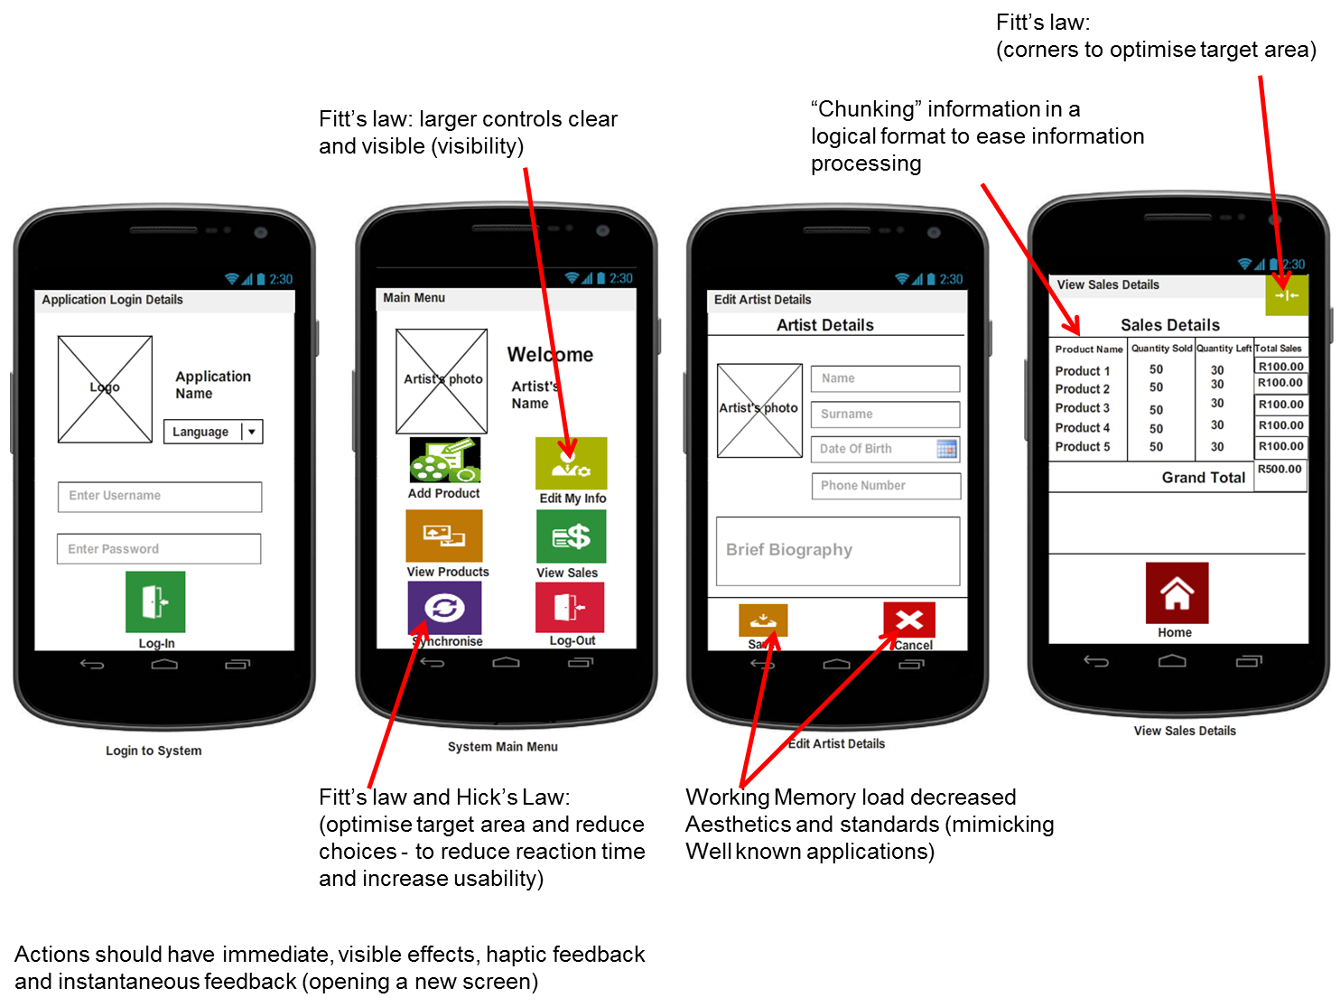

Figure 1: General Interface Designs

### Generic Frameset

The application frameset shall be structured such that there are 3 frames that are dedicated for specific functionality. Frame 1 is used for the action bar. Frames 2 and 3 are used for the applications’ content. Figure 2 is used as a guide for defining the frameset for development of the application,

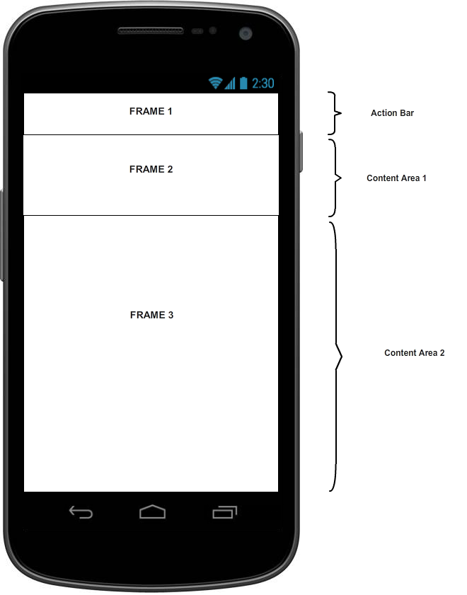

Figure 2: Generic Frameset Sample

### Generic Tables

The usage of tables on the screen is as depicted on the figure below:

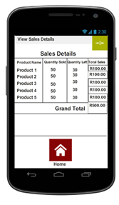

Figure 3 Generic Table

### Generic Forms

The application will use data input forms. There are two input forms that have been defined for iteration 1 and Iteration2.

When the user enters data it will be displayed and the operations that will be affected by this are the login and add product details screens, Figure 4 and 5 respectively. Dedicated areas for adding the picture of the products, input boxes and drop down menu, where applicable, as clearly depicted in Figure 4 and 5 below.

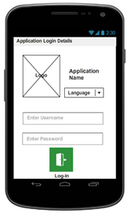

Figure 4: Login Input Form

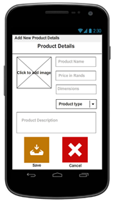

Figure 5: Add Product details Input form

Figure 6, has an input form that is much the same as the Add Product details input form (Figure 5). This allows the artist to change their details.

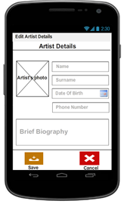

Figure 6: Artist Details Input Form

### Generic Report

Figure 7 and 8, are reports which show saved products and sales details on the mobile application.



Figure 7: Generic Report Sample

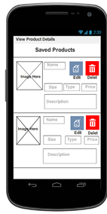

Figure 8 View Product Generic Report Screen

### Application Screens Specification Definitions

#### Iteration 1: Login Screen Specification Definition

|  |  |
| --- | --- |
| **Screen  Name** | **SellMyCraft – Login** |
| **Background Colour** | Moccasin (#FFFEE4B5) |
| **Input Field Font** | Calibri |
| **Input Field Size** | 12 |
| **Input Field Colour** | Black |
| **Input Field Alignment** | Left-aligned |
| **Label Name** | Log-in |
| **Label Positioning** | Centre Aligned |
| **Label Font Type** | Calibri |
| **Label Font Size** | 12 |
| **Icon Name** | **Log In** |
| **Iconography** | C:\Users\g97k5191\Desktop\ITS\Login-Door.png |
| **Icon Size** | 81x81 |
| **Icon Shape** | Square |
| **Icon Colour** | Green (#FF2E913B) |
| **Motif/Logo** | SellMyCraft Logo |
| **Logo Depiction** | C:\Users\g97k5191\Desktop\ITS\sellmycraft.png |
| **Logo Position** | Top left of the Screen |
| **Logo Size** | 91x105 |
| **Label Name** | Application Name |
| **Label Font Type** | Calibri |
| **Label Font Size** | 12 |
| **Label Size** | 98x46 |
| **Label Position** | Left side of the logo position |
| **Drop Down Menu Label Name** | Language |
| **Drop Down Menu Font Type** | Calibri, Bold |
| **Drop Down Menu Font Size** | 12 |
| **Drop Down Menu Size** | 100x25 |
| **Drop Down Menu Font Position** | Below the label and the left side of the Logo position |
| **Created by** | Ntsane Kolisang |
| **Date Created** | 8/08/2013 |
| **Modified By** | Ntsane Kolisang |
| **Date Modified** | 10/09/2013 |



Figure 9 SellMyCraft -Login Screen

#### Iteration 1: Main Menu Application Screen Specification Definition

|  |  |
| --- | --- |
| **Screen  Name** | **Main Menu Screen** |
| **Screen Background Colour** | Moccasin (#FFFEE4B5) |
| **Artist Photo Label Name** | Artist’s Photo |
| **Artist Photo Position** | Top left of the Screen |
| **Artist Photo Size** | 91x105 |
| **Label Name** | **Welcome** |
| **Label Font Type** | Calibri |
| **Label Font Size** | 16 |
| **Label Position** | Left aligned, On the right hand side of the artist photo. |
| **Label Name** | **Artist Name** |
| **Label Font Type** | Calibri |
| **Label Font Size** | 14 |
| **Label Position** | Left aligned, On the right hand side of the artist photo. Below the welcome label. |
| **Icon Name** | **Add Product** |
| **Iconography** | C:\Users\g97k5191\Desktop\ICONS and Mockup Screens\Add Product.PNG |
| **Icon Size** | 81x81 |
| **Icon Shape** | Square |
| **Icon Colour** | Lime green (#FF82BB20), white (#FFFFFFF) and black (#FF000000). |
| **Icon Position** | Left Aligned below the artist photo. |
| **Icon Name** | **View Product** |
| **Iconography** | C:\Users\g97k5191\Desktop\ITS\High-Resolution-Display.png |
| **Icon Size** | 81x81 |
| **Icon Shape** | Square |
| **Icon Colour** | Light Brown (#FFC07807), white (#FFFFFFF) |
| **Icon Position** | Left Aligned directly below Add Product. |
| **Icon Name** | **Synchronise** |
| **Iconography** | C:\Users\g97k5191\Desktop\ITS\Data-Synchronize.png |
| **Icon Size** | 81x81 |
| **Icon Shape** | Square |
| **Icon Colour** | Dark purple (#FF512D7E), White (#FFFFFFF) |
| **Icon Position** | Left Aligned directly below Add Product. |
| **Icon Name** | **Edit My Info** |
| **Iconography** | C:\Users\g97k5191\Desktop\ICONS and Mockup Screens\Boy-01.png |
| **Icon Size** | 81x81 |
| **Icon Shape** | Square |
| **Icon Colour** | Lime green(#FFC07807), White (#FFFFFFF) |
| **Icon Position** | On the right side of Add Product. |
| **Icon Name** | **View Sales** |
| **Iconography** | C:\Users\g97k5191\Desktop\ICONS and Mockup Screens\Money.png |
| **Icon Size** | 81x81 |
| **Icon Shape** | Square |
| **Icon Colour** | Grass Green(#FF2E913B), White (#FFFFFFF) |
| **Icon Position** | On the right side of View Product. |
| **Icon Name** | **Log-Out** |
| **Iconography** | C:\Users\g97k5191\Desktop\ITS\Logout.png |
| **Icon Size** | 81x81 |
| **Icon Shape** | Square |
| **Icon Colour** | Guava red (#FFD51F38), White (#FFFFFFF) |
| **Icon Position** | On the right side of Synchronise |
| **Motif/Logo** | SellMyCraft Logo |
| **Logo Depiction** | C:\Users\g97k5191\Desktop\ITS\sellmycraft.png |
| **Logo Position** | Top left of the Screen |
| **Logo Size** | 60x74 |
| **Created by** | Ntsane Kolisang |
| **Date Created** | 8/08/2013 |
| **Modified By** | Ntsane Kolisang |
| **Date Modified** | 10/09/2013 |

#### Iteration 2: Add New Product Details

|  |  |
| --- | --- |
| **Screen  Name** | **Add New Product Details Screen** |
| **Screen Background Colour** | Moccasin (#FFFEE4B5) |
| **Header Label Name** | Product Details |
| **Header Label Font Type** | Calibri |
| **Header Label Font Size** | 16 |
| **Header Label Font Alignment** | Centre aligned |
| **Product Name Input Field Label name** | Product Name |
| **Product Name Input Field Font** | Calibri |
| **Product Name Input Field Size** | 86x20 |
| **Product Name Input Field Colour** | Black |
| **Product Input Field Alignment** | Left-aligned |
| **Product Name Input Field position** | On the left side of the product’s image |
| **Product Price Input Mask for Currency** | R 0.00 |
| **Product Price Input Type** | Integer |
| **Product Price Input Field Label** | Price in Rands |
| **Product Price Input Field Size** | 86x20 |
| **Product Dimensions Input Field Font** | Calibri |
| **Product Dimensions Input Field Size** | 86x20 |
| **Product Dimensions Input Field Colour** | Black |
| **Product Dimensions Input Field Justification** | Left-aligned |
| **Product Dimensions Input Field position** | On the left side of the product’s image |
| **Product Dimensions Input Field Label Name** | Dimensions |
| **Drop Down Manu Label Name** | Product Type |
| **Drop Down Menu Font Type** | Calibri, Bold |
| **Drop Down Menu Font Size** | 12 |
| **Drop Down Menu Size** | 86x20 |
| **Drop Down Menu Font Position** | Below the label and the left side of the Logo position |
| **Product Description Input Label Name** | Product Description |
| **Product Description Input Field Size** | 250x66 |
| **Product Description Input Field Colour** | Black |
| **Product Description Input Field Justification** | Justified |
| **Product Description Input Field position** | Left Justified below Product Type Drop Down Menu |
| **Product image Label name** | Click to add image |
| **Product Image Position** | Top left of the Screen |
| **Product Image Photo Size** | 91x105 |
| **Icon Name** | Save |
| **Iconography** | C:\Users\g97k5191\Desktop\ITS\Save.png |
| **Icon Size** | 81x81 |
| **Icon Shape** | Square |
| **Icon Colour** | Brown(#FFC07807), White (#FFFFFFF) |
| **Icon Position** | Bottom Left below Product Description |
| **Icon label Name** | Cancel |
| **Iconography** | C:\Users\g97k5191\Desktop\ITS\Delete.png |
| **Icon Size** | 81x81 |
| **Icon Shape** | Square |
| **Icon Colour** | Dark red (#FFC07807), White (#FFFFFFF) |
| **Icon Position** | Bottom Right below Product Description |
| **Motif/Logo** | SellMyCraft Logo |
| **Logo Depiction** | C:\Users\g97k5191\Desktop\ITS\sellmycraft.png |
| **Logo Position** | Top left of the Screen |
| **Logo Size** | 60x74 |
| **Created by** | Ntsane Kolisang |
| **Date Created** | 8/08/2013 |
| **Modified By** | Ntsane Kolisang |
| **Modified On** | 10/09/2013 |



Figure 10 Add New Product Details - Save or Cancel

|  |  |
| --- | --- |
| **Screen  Name** | **Edit Artist Details** |
| **Screen Background Colour** | Moccasin (#FFFEE4B5) |
| **Header Label Name** | Artist Details |
| **Header Label Font Type** | Calibri |
| **Header Label Font Size** | 16 |
| **Header Label Font Alignment** | Centre aligned |
| **Artist Name Input Field Label name** | Name |
| **Artist Name Input Field Font** | Calibri |
| **Artist Name Input Field Size** | 86x20 |
| **Artist Name Input Field Colour** | Black |
| **Artist Name Input Field alignment** | Left-aligned |
| **Artist Name Input Field position** | On the left side of the Artist’s image |
| **Artist Surname Input Field Label name** | Name |
| **Artist Surname Input Field Font** | Calibri |
| **Artist Surname Input Field Size** | 86x20 |
| **Artist Surname Input Field Colour** | Black |
| **Artist Surname Input Field alignment** | Left-aligned |
| **Artist Surname Input Field position** | On the left side of the Artist’s image |
| **Date of Birth Label name** | Date of Birth |
| **Date of Birth Label Font** | Calibri |
| **Date of Birth Size** | 86x20 |
| **Artist Surname Input Field Colour** | Black |
| **Date of Birth Picker ( Use Date Picker)** | Date Picker |
| **Date Picker size** | 20x23 |
| **Date Picker position** | On the left side of the date of birth label |
| **Phone Number Label** | Phone Number |
| **Phone Number Input Field Font** | Calibri |
| **Phone Number Input Field Size** | 86x20 |
| **Phone Number Input Position** | Below Date Of Birth |
| **Phone Number Font Colour** | Black |
| **Phone Number Font Alignment** | Left-aligned |
| **Artist Biography Input Field Label** | Brief Biography |
| **Artist Biography Input Field position** | On the left side of the product’s image |
| **Artist Biography Input Field Size** | 250x66 |
| **Artist Biography Input Field Colour** | Black |
| **Artist Biography Input Field Alignment** | Justified |
| **Artist Biography Input Field position** | Left Justified below phone number. |
| **Artist photo Label name** | Click to add a picture |
| **Artist photo Position** | Top left of the Screen |
| **Artist Photo Size** | 91x105 |
| **Icon Name** | Gallery |
| **Iconography** | C:\Users\g97k5191\Desktop\ITS\High-Resolution-Display.png |
| **Icon Size** | 81x81 |
| **Icon Shape** | Square |
| **Icon Colour** | Light Brown(#FFC07807), White (#FFFFFFF) |
| **Icon Position** | Bottom Left below Product Description |
| **Icon label Name** | Camera |
| **Iconography** | C:\Users\g97k5191\Desktop\ITS\Camera-01.png |
| **Icon Size** | 81x81 |
| **Icon Shape** | Square |
| **Icon Colour** | Orange (#FF9821D), White (#FFFFFFF) |
| **Icon Position** | Bottom Right below Product Description |
| **Motif/Logo** | SellMyCraft Logo |
| **Logo Depiction** | C:\Users\g97k5191\Desktop\ITS\sellmycraft.png |
| **Logo Position** | Top left of the Screen |
| **Logo Size** | 60x74 |
| **Created by** | Ntsane Kolisang |
| **Date Created** | 8/08/2013 |
| **Modified By** | Ntsane Kolisang |
| **Modified On** | 10/09/2013 |

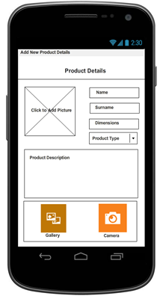

Figure 11 Add New Product - Gallery or Camera Screen

|  |  |
| --- | --- |
| **Screen  Name** | **Add New Product ->Camera Picture Preview Screen** |
| **Screen Background Colour** | Moccasin (#FFFEE4B5) |
| **Label-1 Name** | Do you want to save the picture? |
| **Label-1 Font Type** | Calibri |
| **Label-1 Font Size** | 12 |
| **Label-1 Font Alignment** | Centre aligned |
| **Label-1 Position** | Below the Picture Preview |
| **Artist photo Size** | 299x262 |
| **Artist photo Position** | To Fill 60% of the Camera Screen |
| **Icon Name** | Yes |
| **Icon Label Position** | Below the Yes Iconography, Centre Aligned |
| **Iconography** | C:\Users\g97k5191\Desktop\ITS\Yes.png |
| **Icon Size** | 81x81 |
| **Icon Shape** | Square |
| **Icon Colour** | Dark Green(#FF1F7246), White (#FFFFFFF) |
| **Icon Position** | Below label-1 |
| **Icon label Name** | Take Another |
| **Iconography** | C:\Users\g97k5191\Desktop\ITS\Camera-01.png |
| **Icon Size** | 81x81 |
| **Icon Shape** | Square |
| **Icon Colour** | Orange (#FF9821D), White (#FFFFFFF) |
| **Icon Position** | Below label-1 |
| **Icon label Name** | Cancel |
| **Iconography** | C:\Users\g97k5191\Desktop\ITS\Delete.png |
| **Icon Size** | 81x81 |
| **Icon Shape** | Square |
| **Icon Colour** | Dark red (#FFC07807), White (#FFFFFFF) |
| **Icon Position** | Below label-1 |
| **Motif/Logo** | SellMyCraft Logo |
| **Logo Depiction** | C:\Users\g97k5191\Desktop\ITS\sellmycraft.png |
| **Logo Position** | Top left of the Screen |
| **Logo Size** | 60x74 |
| **Created by** | Ntsane Kolisang |
| **Date Created** | 8/08/2013 |
| **Modified By** | Ntsane Kolisang |
| **Modified On** | 10/09/2013 |

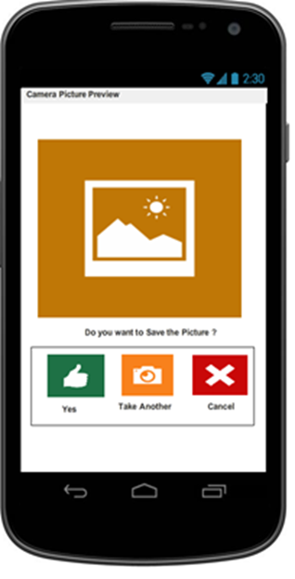

Figure 12 Add New Product Camera Preview Screen

#### Iteration 2: View Product Details

|  |  |
| --- | --- |
| **Screen  Name** | **View Product Details Screen** |
| **Screen Background** | Moccasin (#FFFEE4B5) |
| **Header Label Name** | Saved Products |
| **Header Label Font Type** | Calibri |
| **Header Label Font Size** | 16 |
| **Header Label Font Alignment** | Left aligned |
| **Header Label Position** | Centre Align |
| **Product Image Label Name** | Image Here |
| **Product Image Position** | Left side of the Screen |
| **Product Image Photo Size** | 91x105 |
| **Product name Label** | Name |
| **Product name Label Font** | Calibri |
| **Product name Label Size** | 86x20 |
| **Product name Label Colour** | Black |
| **Product name Label Alignment** | Left-aligned |
| **Product name Label Position** | On the left side of the product’s image and on the left side of the Edit Icon. |
| **Icon Label Name** | **Edit** |
| **Icon Label Font** | Calibri |
| **Icon Label Size** | 27x20 |
| **Icon Label Colour** | Black |
| **Icon Label Alignment** | Left-aligned |
| **Icon Label Position** | Below the Edit Icon |
| **Iconography** | C:\Users\g97k5191\Desktop\ITS\Edit.png |
| **Icon Size** | 42x42 |
| **Icon Shape** | Square |
| **Icon Colour** | Blue Grey (#FF728EB0), White (#FFFFFFF) |
| **Icon Position** | Between the Label and the Delete Icon |
| **Icon Label Name** | **Delete** |
| **Icon Label Font** | Calibri |
| **Icon Label Size** | 27x20 |
| **Icon Label Colour** | Black |
| **Icon Label Alignment** | Left-aligned |
| **Icon Label Position** | Below the Delete Icon |
| **Iconography** | C:\Users\g97k5191\Desktop\ITS\Garbage.png |
| **Icon Size** | 42x42 |
| **Icon Shape** | Square |
| **Icon Colour** | Red (#FFFF0000), White (#FFFFFFF) |
| **Icon Position** | Between the Label and the Delete Icon |
| **Product Size Label Name** | Size |
| **Product Size Label Font** | Calibri |
| **Product Size Label Size** | 54x24 |
| **Product Size Label Colour** | Black |
| **Product Size Label Alignment** | Left-aligned |
| **Product Size Label Position** | On the left side of the product’s image and on the right side of Product Type Label |
| **Product Type Label Name** | Type |
| **Product Type Label Font** | Calibri |
| **Product Type Label Size** | 54x24 |
| **Product Type Label Colour** | Black |
| **Product Type Label Alignment** | Left-aligned |
| **Product Type Label Position** | On the left side of the product’s image, below the edit Icon and on the right side of Product Price Label |
| **Product Price Label Name** | Price |
| **Product Price Label Font** | Calibri |
| **Product Price Label Size** | 54x24 |
| **Product Price Label Colour** | Black |
| **Product Price Label Alignment** | Left-aligned |
| **Product Price Label Position** | On the left side of product Type label and below the delete Icon. |
| **Product Description Label Name** | Product Description |
| **Product Description Size** | 160x45 |
| **Product Description Font Colour** | Black |
| **Product Description Text Alignment** | Justified |
| **Product Description Position** | Directly Below Product Size, Type and Price labels. |
| **Motif/Logo** | SellMyCraft Logo |
| **Logo Depiction** | C:\Users\g97k5191\Desktop\ITS\sellmycraft.png |
| **Logo Position** | Top left of the Screen |
| **Logo Size** | 60x74 |
| **Created by** | Ntsane Kolisang |
| **Date Created** | 8/08/2013 |
| **Modified By** | Ntsane Kolisang |
| **Modified On** | 10/09/2013 |



Figure 13 View Product Details

#### Iteration 2: Edit Artist Details

|  |  |
| --- | --- |
| **Screen  Name** | **Edit Artist Details ->Save or Delete Captured Information** |
| **Screen Background Colour** | Moccasin (#FFFEE4B5) |
| **Header Label Name** | Artist Details |
| **Header Label Font Type** | Calibri |
| **Header Label Font Size** | 16 |
| **Header Label Font Alignment** | Centre aligned |
| **Artist Name Input Field Label name** | Name |
| **Artist Name Input Field Font** | Calibri |
| **Artist Name Input Field Size** | 86x20 |
| **Artist Name Input Field Colour** | Black |
| **Artist Name Input Field alignment** | Left-aligned |
| **Artist Name Input Field position** | On the left side of the Artist’s image |
| **Artist Surname Input Field Label name** | Name |
| **Artist Surname Input Field Font** | Calibri |
| **Artist Surname Input Field Size** | 86x20 |
| **Artist Surname Input Field Colour** | Black |
| **Artist Surname Input Field alignment** | Left-aligned |
| **Artist Surname Input Field position** | On the left side of the Artist’s image |
|  |  |
| **Date of Birth Label name** | Date of Birth |
| **Date of Birth Label Font** | Calibri |
| **Date of Birth Size** | 86x20 |
| **Artist Surname Input Field Colour** | Black |
| **Date of Birth Picker ( Use Date Picker)** | Date Picker |
| **Date Picker size** | 20x23 |
| **Date Picker position** | On the left side of the date of birth label |
| **Phone Number Label** | Phone Number |
| **Phone Number Input Field Font** | Calibri |
| **Phone Number Input Field Size** | 86x20 |
| **Phone Number Input Position** | Below Date Of Birth |
| **Phone Number Font Colour** | Black |
| **Phone Number Font Alignment** | Left-aligned |
| **Artist Biography Input Field Label** | Brief Biography |
| **Artist Biography Input Field position** | On the left side of the product’s image |
| **Artist Biography Input Field Size** | 250x66 |
| **Artist Biography Input Field Colour** | Black |
| **Artist Biography Input Field Alignment** | Justified |
| **Artist Biography Input Field position** | Left Justified below phone number. |
| **Artist photo Label name** | Click to add a picture |
| **Artist photo Position** | Top left of the Screen |
| **Artist Photo Size** | 91x105 |
| **Icon Name** | Save |
| **Iconography** | C:\Users\g97k5191\Desktop\ITS\Save.png |
| **Icon Size** | 81x81 |
| **Icon Shape** | Square |
| **Icon Colour** | Brown(#FFC07807), White (#FFFFFFF) |
| **Icon Position** | Bottom Left below Product Description |
| **Icon label Name** | Cancel |
| **Iconography** | C:\Users\g97k5191\Desktop\ITS\Delete.png |
| **Icon Size** | 81x81 |
| **Icon Shape** | Square |
| **Icon Colour** | Dark red (#FFC07807), White (#FFFFFFF) |
| **Icon Position** | Bottom Right below Product Description |
| **Motif/Logo** | SellMyCraft Logo |
| **Logo Depiction** | C:\Users\g97k5191\Desktop\ITS\sellmycraft.png |
| **Logo Position** | Top left of the Screen |
| **Logo Size** | 60x74 |
| **Created by** | Ntsane Kolisang |
| **Date Created** | 8/08/2013 |
| **Modified By** | Ntsane Kolisang |
| **Modified On** | 10/09/2013 |

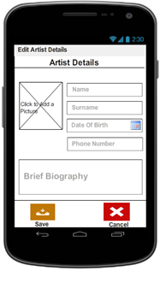

Figure 14 Edit My Info Screen- Save or Cancel Captured Data

|  |  |
| --- | --- |
| **Screen  Name** | **Edit Artist Details** |
| **Screen Background Colour** | Moccasin (#FFFEE4B5) |
| **Header Label Name** | Artist Details |
| **Header Label Font Type** | Calibri |
| **Header Label Font Size** | 16 |
| **Header Label Font Alignment** | Centre aligned |
| **Artist Name Input Field Label name** | Name |
| **Artist Name Input Field Font** | Calibri |
| **Artist Name Input Field Size** | 86x20 |
| **Artist Name Input Field Colour** | Black |
| **Artist Name Input Field alignment** | Left-aligned |
| **Artist Name Input Field position** | On the left side of the Artist’s image |
| **Artist Surname Input Field Label name** | Name |
| **Artist Surname Input Field Font** | Calibri |
| **Artist Surname Input Field Size** | 86x20 |
| **Artist Surname Input Field Colour** | Black |
| **Artist Surname Input Field alignment** | Left-aligned |
| **Artist Surname Input Field position** | On the left side of the Artist’s image |
| **Date of Birth Label name** | Date of Birth |
| **Date of Birth Label Font** | Calibri |
| **Date of Birth Size** | 86x20 |
| **Artist Surname Input Field Colour** | Black |
| **Date of Birth Picker ( Use Date Picker)** | Date Picker |
| **Date Picker size** | 20x23 |
| **Date Picker position** | On the left side of the date of birth label |
| **Phone Number Label** | Phone Number |
| **Phone Number Input Field Font** | Calibri |
| **Phone Number Input Field Size** | 86x20 |
| **Phone Number Input Position** | Below Date Of Birth |
| **Phone Number Font Colour** | Black |
| **Phone Number Font Alignment** | Left-aligned |
| **Artist Biography Input Field Label** | Brief Biography |
| **Artist Biography Input Field position** | On the left side of the product’s image |
| **Artist Biography Input Field Size** | 250x66 |
| **Artist Biography Input Field Colour** | Black |
| **Artist Biography Input Field Alignment** | Justified |
| **Artist Biography Input Field position** | Left Justified below phone number. |
| **Artist photo Label name** | Click to add a picture |
| **Artist photo Position** | Top left of the Screen |
| **Artist Photo Size** | 91x105 |
| **Icon Name** | Gallery |
| **Iconography** | C:\Users\g97k5191\Desktop\ITS\High-Resolution-Display.png |
| **Icon Size** | 81x81 |
| **Icon Shape** | Square |
| **Icon Colour** | Light Brown(#FFC07807), White (#FFFFFFF) |
| **Icon Position** | Bottom Left below Product Description |
| **Icon label Name** | Camera |
| **Iconography** | C:\Users\g97k5191\Desktop\ITS\Camera-01.png |
| **Icon Size** | 81x81 |
| **Icon Shape** | Square |
| **Icon Colour** | Orange (#FF9821D), White (#FFFFFFF) |
| **Icon Position** | Bottom Right below Product Description |
| **Motif/Logo** | SellMyCraft Logo |
| **Logo Depiction** | C:\Users\g97k5191\Desktop\ITS\sellmycraft.png |
| **Logo Position** | Top left of the Screen |
| **Logo Size** | 60x74 |
| **Created by** | Ntsane Kolisang |
| **Date Created** | 8/08/2013 |
| **Modified By** | Ntsane Kolisang |
| **Modified On** | 10/09/2013 |

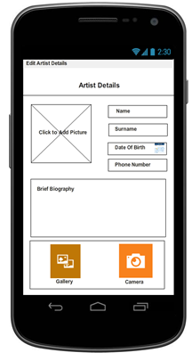

Figure 15 Edit My Info Capturing - Choose Camera or Gallery Screen

|  |  |
| --- | --- |
| **Screen  Name** | **Edit Artist Details->Camera Picture Preview Screen** |
| **Screen Background Colour** | Moccasin (#FFFEE4B5) |
| **Label-1 Name** | Do you want to save the picture? |
| **Label-1 Font Type** | Calibri |
| **Label-1 Font Size** | 12 |
| **Label-1 Font Alignment** | Centre aligned |
| **Label-1 Position** | Below the Picture Preview |
| **Artist photo Size** | 299x262 |
| **Artist photo Position** | To Fill 60% of the Camera Screen |
| **Icon Name** | Yes |
| **Icon Label Position** | Below the Yes Iconography, Centre Aligned |
| **Iconography** | C:\Users\g97k5191\Desktop\ITS\Yes.png |
| **Icon Size** | 81x81 |
| **Icon Shape** | Square |
| **Icon Colour** | Dark Green(#FF1F7246), White (#FFFFFFF) |
| **Icon Position** | Below label-1 |
| **Icon label Name** | Take Another |
| **Iconography** | C:\Users\g97k5191\Desktop\ITS\Camera-01.png |
| **Icon Size** | 81x81 |
| **Icon Shape** | Square |
| **Icon Colour** | Orange (#FF9821D), White (#FFFFFFF) |
| **Icon Position** | Below label-1 |
| **Icon label Name** | Cancel |
| **Iconography** | C:\Users\g97k5191\Desktop\ITS\Delete.png |
| **Icon Size** | 81x81 |
| **Icon Shape** | Square |
| **Icon Colour** | Dark red (#FFC07807), White (#FFFFFFF) |
| **Icon Position** | Below label-1 |
| **Motif/Logo** | SellMyCraft Logo |
| **Logo Depiction** | C:\Users\g97k5191\Desktop\ITS\sellmycraft.png |
| **Logo Position** | Top left of the Screen |
| **Logo Size** | 60x74 |
| **Created by** | Ntsane Kolisang |
| **Date Created** | 8/08/2013 |
| **Modified By** | Ntsane Kolisang |
| **Modified On** | 10/09/2013 |

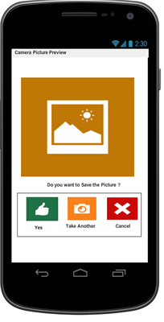

Figure 16 Edit My Info - Take another Picture -Save or Cancel

#### Iteration 3: View Sales

|  |  |
| --- | --- |
| **Screen  Name** | **View Sales** |
| **Screen Background Colour** | Moccasin (#FFFEE4B5) |
| **Header Label Name** | Sales Details |
| **Header Label Font Type** | Calibri |
| **Header Label Font Size** | 16 |
| **Header Label Font Alignment** | Centre aligned |
| **Header Label Position** | Below the Picture Preview |
| **Table** | 1(Row) x 4(Column) Headings |
| **Table Column Heading Names** | Product Name, Quantity Sold, Quantity Left, Total Sales |
| **Table Column Heading Font Type** | Calibri |
| **Table Column Heading Font Size** | 12 |
| **Table Rows Font Type and Size** | Calibri, 12 |
| **Table Grand Total Cell Font Type and Size** | Calibri, 14 |
| **Icon label Name** | Home |
| **Iconography** | C:\Users\g97k5191\Desktop\ITS\Home.png |
| **Icon Size** | 81x81 |
| **Icon Shape** | Square |
| **Icon Colour** | Maroon (#FF880505), White (#FFFFFFF) |
| **Icon Position** | Below The Table, Centre Alighned |
| **Motif/Logo** | SellMyCraft Logo |
| **Logo Depiction** | C:\Users\g97k5191\Desktop\ITS\sellmycraft.png |
| **Logo Position** | Top left of the Screen |
| **Logo Size** | 60x74 |
| **Created by** | Ntsane Kolisang |
| **Date Created** | 8/08/2013 |
| **Modified By** | Ntsane Kolisang |
| **Modified On** | 10/09/2013 |



Figure 17 View Sales Details Screen

## Window Pages: Storyboards

Screen dimensions will vary depending on the Android mobile device being used. Though during development, a 480x800 Nexus S screen resolution will be used on an emulator for both testing and presentations.

### Iteration 1: Use Case 1 User Login

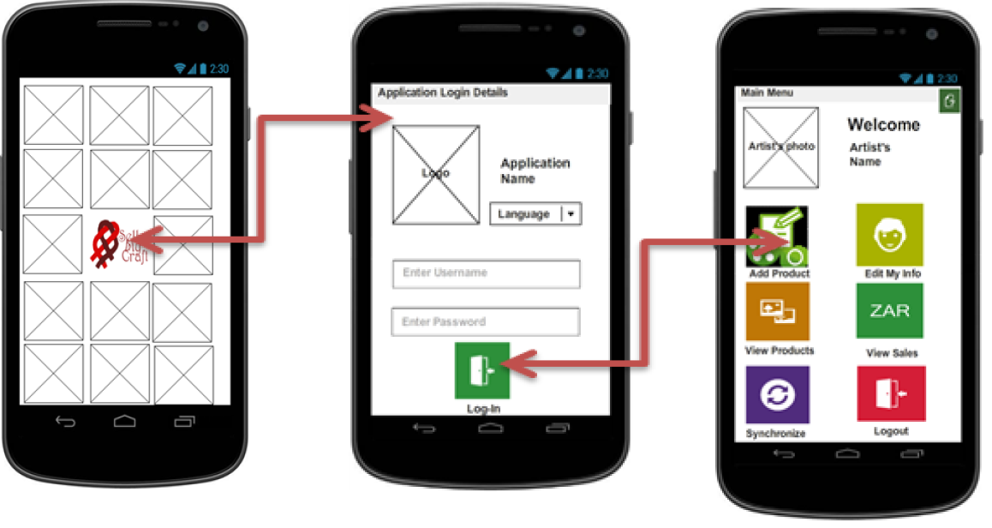

Figure : Iteration 1 Use Case 1 Story Board

### Iteration 2: Use Case 3: Add Product Details

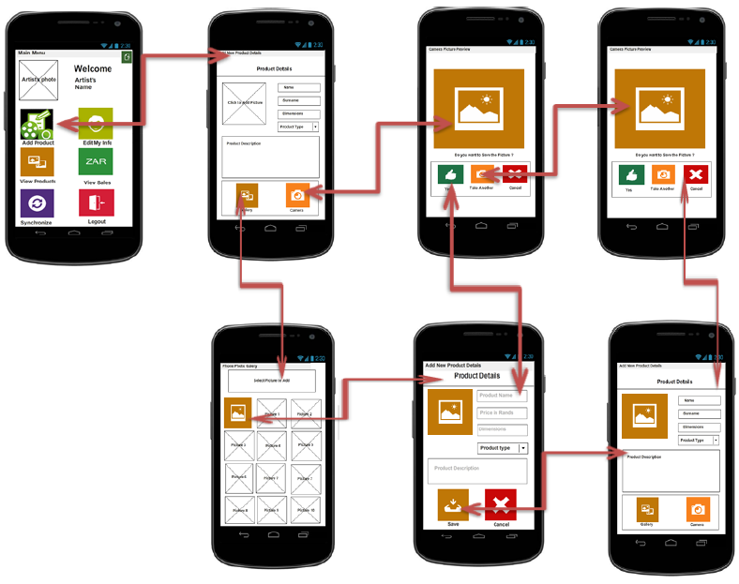

Figure 19: Iteration 2 Use Case 3 Story Board

### Iteration 2: Use Case 4 and 5 View Product Details

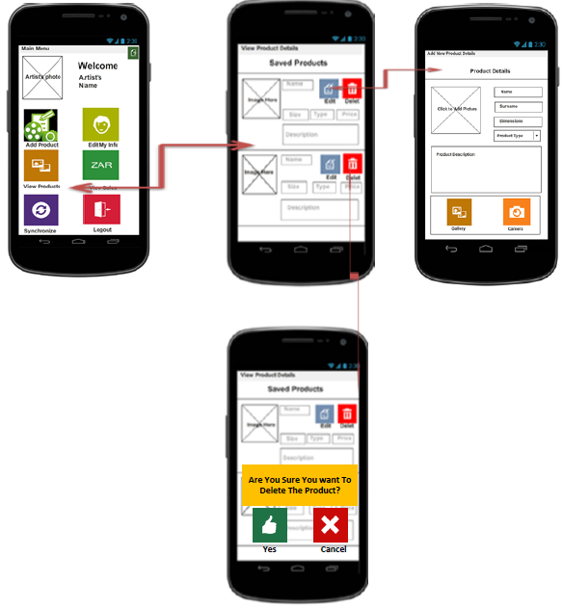

Figure 20: Iteration 2 Use Cases 4 and 5 Story Board

### Iteration 2: Use Case 2 Edit Artist Details

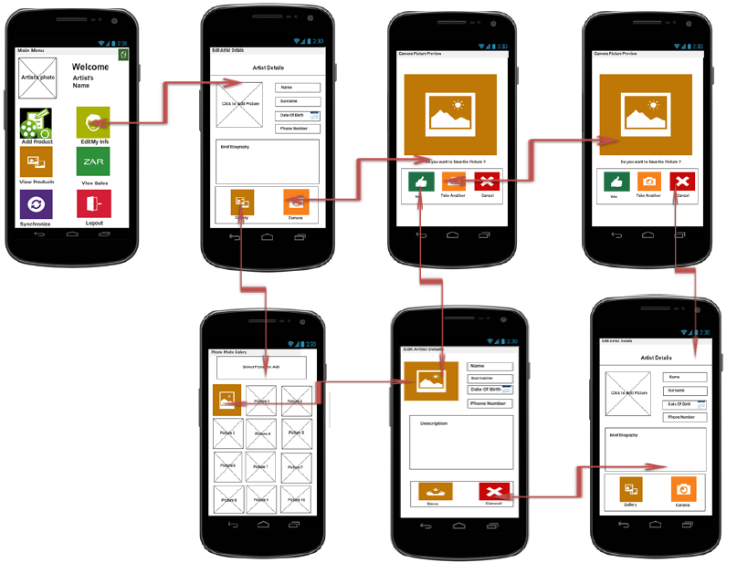

Figure 21 Iteration 2 Use Case 2 Story Board

### Iteration 3: Use Case 6 View Sales

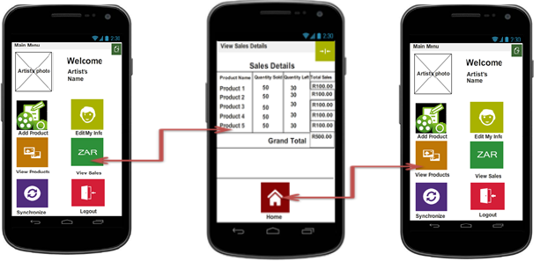

Figure 22 Iteration 3 Use Case 6 Story Board

### Iteration 3: Use Case 8 Synchronisation

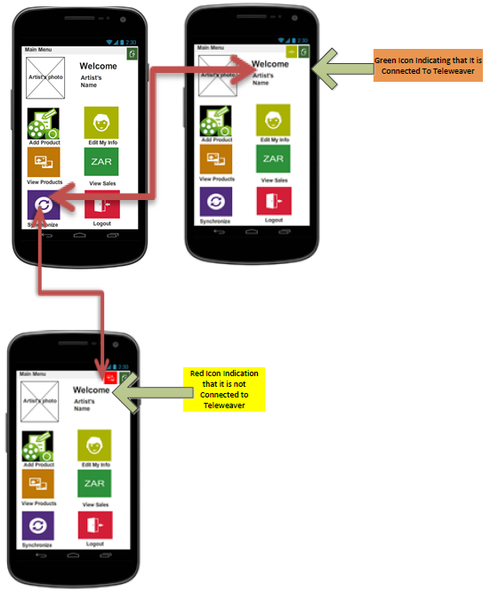

Figure 23 Iteration 3 Use Case 8 Synchronisation

### Iteration 4: Sample Language Localisation Screen

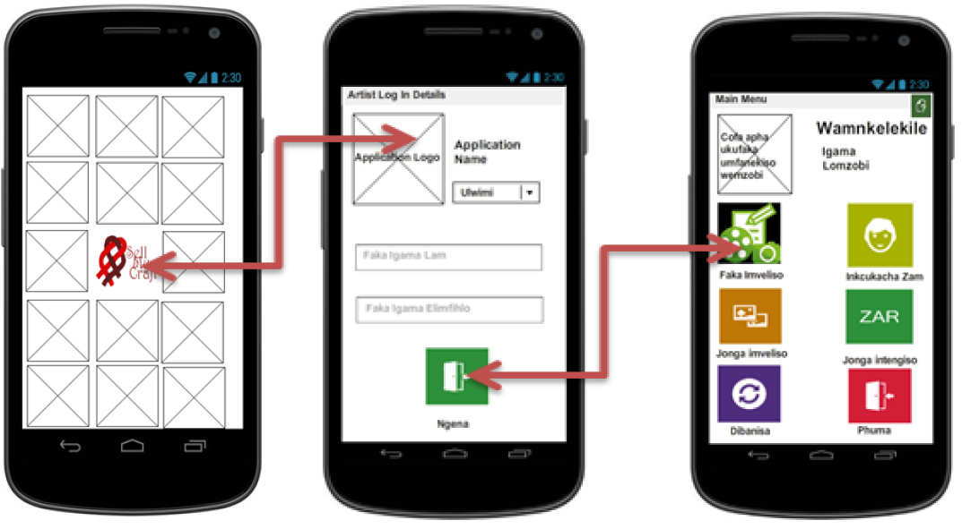

Figure 24 Sample Language Localisation Screen

Table 1 Language Translation List - English to Xhosa

|  |  |  |
| --- | --- | --- |
| **Item 1** | **English** | **Xhosa** |
|  | | |
| **Login Screen** | | |
| 1 | Enter Username | Faka Igama Lam |
| 2 | Enter Password | Faka igama elimfihlo |
| 3 | Enter | Ngena |
| 4 | Language | Ulwimi |
|  | | |
| **Main Menu Screen** | | |
| 5 | Welcome | Wamnkelekile |
| 6 | Add Product | Faka Imveliso |
| 7 | View Product | Jonga Imveliso |
| 8 | View Sales | Jonga Intengiso |
| 9 | Edit My Info | Hlela Inkcukacha Zam |
| 10 | Synchronize | Dibanisa |
| 11 | Logout | Phuma |
|  | | |
| **Add Product Screen** | | |
| 12 | Product Details | Inkcukacha Zemveliso |
| 13 | Product Name | Igama Lemveliso |
| 14 | Enter Product Name | Faka Igama Lemveliso |
| 15 | Price of Product | Ixabiso Lemveliso |
| 16 | Product Type | Umhlobo Wemveliso |
| 17 | Arts | Umzobo |
| 18 | Crafts | Inkcubeko |
| 19 | Dimension | Umlinganiselo wobude |
| 20 | Product Description | Cacisa Umveliso Apha |
| 21 | Click to Add Product Picture | Cofa apha ukufaka umfanekiso wemveliso |
| 22 | Save | Gcina |
| 23 | Delete | Susa |
| 24 | Edit | Lungisa |
| 25 | Gallery | Izithombe EziseFonini |
| 26 | Camera | Thata umfanekisonge Camera |
| 27 | Do you want to save the picture? | Uyafuna ukugcina lomfanekiso? |
| 28 | Yes | Kolungile |
| 29 | Take Another Picture | Thata Isithombe esinye |
| 30 | Cancel | Cima |
|  | | |
| **View Products** | | |
| 31 | View Products | Jonga Imveliso |
| 32 | Saved Products | Imveliso Eciniweyo |
| 33 | Dimensions (size) | Umlinganiso Wobude |
| 34 | Product Type | Umhlobo Wemveliso |
| 35 | Product Price | Ixabiso Lemveliso |
| 36 | Edit | Lungisa |
| 37 | Delete | Susa |
| 38 | Cancel | Cima |
| 39 | Yes | Kolungile |
| 40 | Product Description | Umcaciso Wemveliso |
| 41 | Click to Add Product Image/Picture | Cofa apha ukufaka umfanekiso wemveliso |
| 42 | Are you sure you want to delete the product? | Ucinisekile Ufuna Ukususa Lemveliso? |
|  | | |
| **Edit My Info** | | |
| 38 | Edit My Info | Hlela Inkcukacha Zam |
| 39 | Artist Details | Inkcukacha Zomzobi |
| 40 | Name | Igama |
| 41 | Surname | Ifani |
| 42 | Date of Birth | Umhla Lokuzalwa |
| 43 | Phone Number | Icingo Le Ndaba |
| 44 | Biography | Cacisa Imisebenzi Yakho |
| 45 | Click to Add A New Image/Picture | Cofa apha ukufaka umfanekiso wemveliso |
| 46 | Gallery | Izithombe EziseFonini |
| 47 | Camera | Thata umfanekisonge Camera |
| 48 | Yes | Kolungile |
| 49 | Take Another Picture | Thata Isithombe esinye |
| 50 | Cancel | Cima |
| 51 | Do you want to save this picture? | Uyafuna ukucina umfanekiso? |
|  | | |
| **View Sales** | | |
| 51 | Sales Details | Inkcukacha Ye Ntengiso |
| 52 | Product Name | Igama Lemveliso |
| 53 | Quantity Sold | Ezithengisiweyo |
| 54 | Quantity Left | Ezingathengiswanga |
| 55 | Total Sold | Ixhabiso |
| 56 | Grand Total | Ixhabiso Yazo Zonke |
| 57 | Home | Ekhaya |

## Graphical Application Map – Level Views

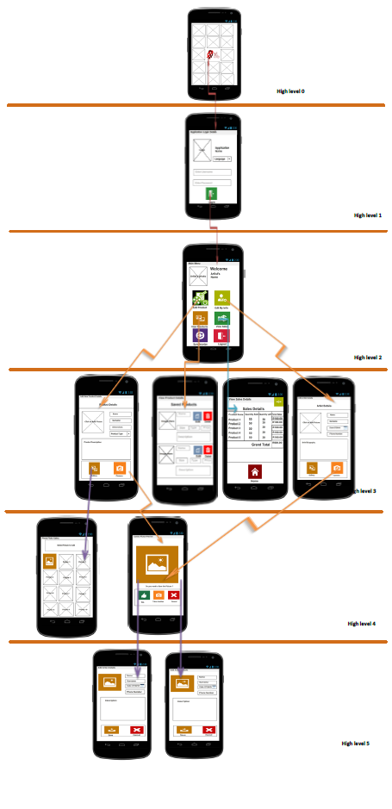

Figure 25: Graphical Application Map

### Permanent Indicators:

Default Android date and/or time on status bar will be visible at all times when application is being utilised.

### User Guidance

* + - 1. The application will provide the user with feedback on current status or mode.
      2. Elements will be highlighted to draw attention of users - especially for critical application statuses.

### Summary Reports

View Sales screen is a report screen indicating the summary of all sales on a table as depicted on use case 6’s story board.

## Use Case/Interface Dependence Matrix

Table 2: Use Case/Interface Dependence Matrix: Iteration 1

|  |  |  |  |
| --- | --- | --- | --- |
| **Interface Name** | **Use Cases** |  |  |
|  | **UC01: Manage Artist** | **UC02: Manage Gallery** | **UC03: Manage Sales** |
| **Main Menu** | Artist | Gallery | Sales |
| **New Product** |  | Picture | Price |
| **Gallery** |  | Picture |  |
| **Sales Overview** |  |  | Product and Sale |

Table 3: Use Case/Interface Dependence Matrix: Iteration 2

|  |  |  |  |
| --- | --- | --- | --- |
| **Interface Name** | **Use Cases** |  |  |
|  | **UC03: Add New Product Details** | **UC04: Manage Product Picture** | **UC05: Manage Product Details** |
| **Main Menu** | Product | Product Picture | Product |
| **New Product Details** | Product | Product Picture |  |
| **View Product Details** |  | Product | Product |

Table 3: Use Case/Interface Dependence Matrix: Iteration 3

|  |  |  |  |
| --- | --- | --- | --- |
| **Interface Name** | **Use Cases** |  |  |
|  | **UC02: Edit Artist Details** | **UC06: View Sales Details** | **UC08: Synchronize with TeleWeaver** |
| **Main Menu** | Artist | Sales |  |
| **Artist Details** | Artist |  |  |
| **View Sales Details** |  | Sale and Product |  |

## User Interface Dialogues

### Screen Navigation

* + - 1. Reverse and forward paging between screens will be possible after user login.
      2. Consistent approaches will be provided to users for manoeuvring within and between screens.

### Screen Layout

It will not be possible for user to personalize screen layout (Screen elements may only vary depending on data related to the user logged in).

## Testing and Usability

Two levels of testing have been performed and each was done to deal with a specific goal in mind.

### Functional Testing

This testing was performed internally by ITSAfrica software engineers and where necessary with technical experts from Reed House Systems. The primary goal for these tests was to deal with all the functionality of the system. The primary was to ensure that the system works in a manner that is free from bugs and meets the specifications.

### Usability Testing

Two types of usability testing were undertaken with the actual end user. The primary reason for this was driven by the demographic of the client and the fact that they are a peculiar client in the sense that they are from a marginalised community.

Paper prototype and mobile device based usability tests revealed that some of the end users were literate while others were not literate at all and by that we mean they could not read and write, even in their own language. These findings lead to changing of the user interface from the usage of buttons and too much wording to usage of icon, colour and incorporation of language localisation.

# Database Design

## Target Database Selection

Basic4Android and Microsoft Access 2010 are the two software tools that are recommended to be used for the implementation phase. The mobile application system will be using Basic4Android, which uses object oriented (Basic) programming language, while the relational database model will be using Microsoft Office Access 2010. Basic4Android was chosen for this project, firstly because we are developing an application that needs to run on mobile devices, secondly it includes all features needed to develop great, real-world Android applications and lastly, amongst a few more, it does not require any runtime libraries.

Here are some of the advantages and disadvantages of using Microsoft Office Access for developing our database design:

#### Advantages:

**Simplicity:** the learning curve is not as steep as it is for programs such as SQL

Server and SQL Lite. If you want to create a database for a personal user, a small business database, or even a single-user application database, Access works well. The program includes a variety of wizards and templates designed to simplify the process of creating databases for different tasks and it is easy to understand.

**Scalability:** Access databases include a size limitation of 2 GB, 32 768 objects and 255 simultaneous users, which is more than enough database size to build our tables in and estimate the database size.

**Data export:** data can be easily imported into a report where needed and it allows for linking information between databases.

#### Disadvantages:

**Difficult to learn:** it is difficult to learn all the rules, containers and queries which pertain to the Access program.

**Careful planning:** the program requires careful planning as it is difficult to makes changes and in some instances, global editing can wipe out thousands of saved records.

The major disadvantage of using Basic4Android is that there is currently lack of support for Object Orientation which simply means that there are no global variables within the sub-routines.

## Relational Database Model Diagram

Figure 26: Relational Database Model Diagram

## Relationship Model

This is the model which illustrates the relationship of all the tables thus far which exist in the application:

[Artist]

**[artistID],**

[name],

[surname],

[dOB],

[briefBiography],

[phoneNum],

[emailAddress],

[artistImage],

CONSTRAINT [PK_Artist] PRIMARY KEY CLUSTERED

CONSTRAINT [FK_Community] FOREIGN KEY CLUSTERED

[ProductSale]

**[productID]**,

[saleID],

[quantity],

[cost],

[Association Class]

[ProductPicture]

**[productPictureID]**,

[productID],

[imageSource],

[size],

[uploaded?],

CONSTRAINT [PK_ProductPicture] PRIMARY KEY CLUSTERED

CONSTRAINT [FK_Product] FOREIGN KEY CLUSTERED

[Sale]

**[saleID]**,

[date],

[totalCost]

CONSTRAINT [PK_saleID] PRIMARY KEY CLUSTERED

[Community]

**[communityID]**,

[name],

[logo],

[location],

[artistID],

CONSTRAINT [PK_communityID] PRIMARY KEY CLUSTERED

[Product]

**[productID]**,

[productName],

[dimensions],

[price],

[description]

[type],

[quantityAvailable],

[picture]

CONSTRAINT [PK_productID] PRIMARY KEY CLUSTERED

CONSTRAINT [FK_ProductPicture] FOREIGN KEY CLUSTERED

## Database Size

The database size has grown to 6 tables. The following is a method which was used to calculate the total database size in Bits.

Table 4: Database Size (Artist)

|  |  |
| --- | --- |
| **Artist** | **Characters** |
| artistID | long integer |
| name | 50 |
| surname | 50 |
| DOB | 20 |
| briefBiography | 150 |
| phoneNumber | 20 |
| altPhoneNumber | 20 |
| emailAddress | 50 |
| artistImage | 255 |
| **Total** | **615** |

Table 5: Database Size (Product)

|  |  |
| --- | --- |
| **Product** | **Characters** |
| productID | long integer |
| productName | 100 |
| size | 20 |
| price | 10 |
| description | 254 |
| type | 50 |
| quantityAvailable | 20 |
| picture | 255 |
| artistID | 20 |
| **Total** | **729** |

Table 6: Database Size (ProductPicture)

|  |  |
| --- | --- |
| **ProductPicture** | **Characters** |
| ProductPictureID | long integer |
| productID | 20 |
| **Total** | **20** |

Table 7: Database Size (ProductSale)

|  |  |
| --- | --- |
| **ProductSale** | **Characters** |
| productID | long integer |
| saleID | 20 |
| Quantity | 20 |
| **Total** | **40** |

Table 8: Database Size (Sale)

|  |  |
| --- | --- |
| **Sale** | **Characters** |
| saleID | long integer |
| Date | 20 |
| amountTotal | 10 |
| **Total** | **30** |

Table 9: Database Size (Community)

|  |  |
| --- | --- |
| **Community** | **Characters** |
| communityID | long integer |
| name | 200 |
| location | 100 |
| logo | 255 |
| **Total** | **555** |

Table 8: Database Size (Total)

|  |  |
| --- | --- |
| **Total no. of chr * (rows)** | **Characters** |
| artist(50) | 30750 |
| product(1500) | 1093500 |
| product picture(1000) | 20000 |
| product sale(500) | 20000 |
| sale(700) | 21000 |
| community(10) | 5550 |
| **Total Bytes** | **1190800** |

Table 10: Database Size (Tables)

|  |  |
| --- | --- |
| **Tables** | **Total Bits size** |
| artist | 246000 |
| product | 8748000 |
| productPicture | 160000 |
| productSales | 160000 |
| sale | 168000 |
| community | 44400 |
| **Total bits size** | **9526400** |

From this calculated sizes of each table, it was worked out that the whole database size is currently **9 526 400 in bits.**

In **three years’** time, it is expected to be **28 579 200 in bits**.

In the next **five years**, it is expected to be **47 632 000 in bits** as well.

Percentage increase for the **year 5 is 80%** for the database size calculated from Bits.

# Security and Control Design

## Threats

### The following are the factors that we think will pose major threats to the system:

* Unwarranted users gaining access to legitimate users’ identification and passwords
* Viruses
* Fires, Floods and natural disasters
* Power Outages (In terms of the phone battery running empty)
* Theft- the system will be initially run on a few test purposed mobile devices which support Android before being launched off to mobile devices which might be running other platforms which should be compatible with the android platform.
* Software clashes- Other newly installed software might affect the system if these two clash or the coding does not link.

### Preventative Strategies that we have suggested are:

* Frequently backing up the system data
* Keep back-ups somewhere else other than the location of the system
* Consult an IT technician before installing any software
* Have fire-security measures in place to protect electrical equipment

## Audit Trails

This is just the front-end of the overall Egazini e-commerce project. Therefore, it does not deal with any sales transactions as the payment/sales processing are handled by the back-end or the final retailer.

However, the system will handle sales notification through notifying the Egazini artist of any purchase that occurs with regards to their products.

## System access and Control

In order for the user to be able to access the Egazini mobile application system, they will need to enter their username and password into the input fields within the ‘Login window’. Access to the system will be granted based on the recognition of the details that have been entered by the user with the ones that have been stored on the TeleWeaver database. Furthermore, access to some areas of the system will be granted based on the role that each user plays on the system.

The access restrictions to areas of the system that are not important to certain users signify an enhancement in data integrity and prevent any unauthorized users from tampering with valuable information. The end-users of the application will be classified as User in terms of Roles, while TeleWeaver on the other hand will be allocated the Administrator role, as full runners of the application and maintaining it.

## Back-up and recovery facilities

The system has two databases that synchronize with each other, one being the smaller, program specific database and the other being the main central database handled by TeleWeaver. As such, any backup and recovery facilities of the central database will be handled by TeleWeaver.

However, on our system there will be a basic backup and recovery facility in terms of being able to undo any minor alterations to the database, and the ability to press the back button before any change has been committed. In terms of backup, you will be able to restore the database to its previous state before the current session.

# Environment Design Specifications

## Architectural Layer Design

The primary concern of the project is to create the front-end application which will be linked through the TeleWeaver network (using Wifi), to a database which is concerned with the back-end database. This is a mobile application that will be created using Basic4Android software, and connected to the network via Wifi when in range of a TeleWeaver access node. The mobile application will also need to have an internal database that will be able to store information offline until the application is able to connect to the TeleWeaver back-end, in the vicinity of a TeleCentre.

Once connected to the network input will be sent to the server for processing. This includes data storage, data access logic, application logic and presentation logic. We will base our design on a 3-tier architecture, with one server being responsible for data storage temporarily (acting as a buffer), the business logic layer which will essentially look at the processing of the inputs that the user sends in from the front-end and translating them into a language that the computer can understand and the last being the application or presentation layer, which will be the interaction between the user and the system. The following is an image that explains this diagrammatically:

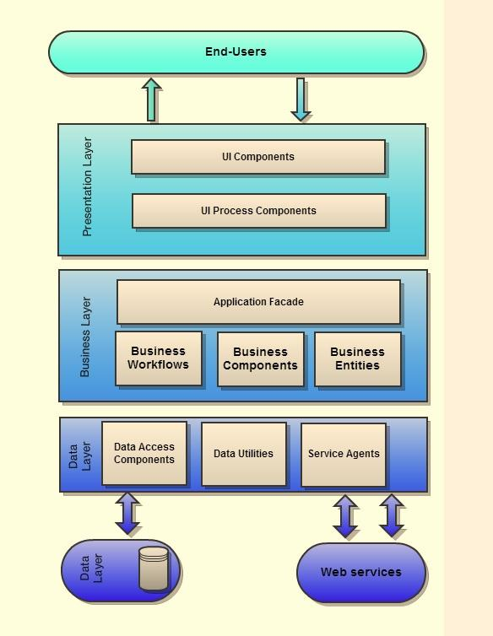

Figure 27: Architectural Layer Design

## Hardware Platform

Android devices running the Android 2.2 operating system. This ranges from Sony Ericsson to Samsung mobile phones.

Table 11: Hardware Platform (Android)

|  |  |  |
| --- | --- | --- |
|  | **Minimum** | **Recommended** |
| **Processor** | 500 MHz | 1 GHz |
| **Memory** | 256 Mb | 512 Mb |
| **Storage** | 1 Gb | 4 Gb |
| **Display resolution** | 256 K colors  240 x 320 pixels, 3.0 inches (~133 ppi pixel density) | 16 M colors  480 x 800 pixels, 3.8 inches (~246 ppi pixel density) |
| **Network Interface** | Wi-Fi 802.11 b/g/n  v2.1 with A2DP | Wi-Fi 802.11 b/g/n  v2.1 with A2DP |
| **Additional requirements** | Camera | 5 Megapixel Camera |

The application will be developed using Windows desktop computers, and then deployed onto mobile phones (this is included to illustrate the minimum requirements needed for the computer to run the program used to build the application).

Table 12: Hardware Platform (Windows Desktop)

|  |  |  |
| --- | --- | --- |
|  | **Minimum** | **Recommended** |
| **Processor** | 500 MHz | 2 GHz |
| **Memory** | 1 Gb | 4 Gb |
| **Storage** | 2 Gb | 5 Gb |
| **Display Resolution** | 1024 x 576 | 1280 x 720 |
| **Network Interface** | 10/100 LAN | 10/100/1000 LAN |
| **Additional Requirements** | Keyboard  Mouse  Monitor  Printer | Keyboard  Mouse (optical)  Monitor (HD)  Printer (Laser) |

## 

## Operating System Platforms

The operating system will be Android which is open source software, which can be freely modified and distributed. The mobile will need to be Java enabled.

Table 13: Operating System Platform

|  |  |  |
| --- | --- | --- |
|  | **Minimum** | **Recommended** |
| **Operating System** | Android 2.1 | Android 4.2 |
| **Web Browser** | Microsoft IE 8 | Mozilla Firefox 12 |
| **Runtime Software** | Basic4Android | Basic4Android |

## Third Party Software Consideration

Java and Linux add-ins will need to be considered for both the Windows desktop and the mobile phones involved.

## Network Platforms

The mobile device will need to have access to Telecommunication network via Wi-Fi, which will enable access to TeleWeaver’s abstraction layer. Mobile Application connection and communication will be enabled through Web Services and specifically using RESTful (REpresentation State Transfer) Web Services.

## Help Design

The project team will endeavour to create an application that is user friendly and extremely intuitive for users. We will ensure this is advocated by regular user testing to achieve this outcome.

Help will be accessible through the information icon available at the top right hand corner of each window. General help on how to use the mobile application will be accessible on the Home screen while specific help to perform specific tasks will be accessible on the specific windows that these tasks are carried out.

The help facility has been implemented taking into account the difficulties that the users may face while using the mobile application. This was done through identifying aspects of application that the user will interact with and may need help or ratification to do so. Where necessary, examples were used to illustrate how various tasks are performed. The help function is completely in-built into the application and will not need an internet connection or additional services to function.

The help icon can be found on the top right hand corner of the Home screen. The icon is shown below.



The help structure that was used is detailed below.

Help tree:

1. Product Overview
   1. Introduction to System
2. Installing and upgrading
   1. Installing System
   2. Upgrading System/Synchronisation
3. Getting started
   1. Artist
      1. View Artist Details
      2. Edit Artist Details
   2. Product
      1. Add Product
      2. View Product
      3. Edit Product Details
      4. Delete Product
      5. Upload Product Picture
   3. Sales
      1. View Sales Reports

All the details on the help feature are contained in the user manual which has been submitted with the Project Management documents.

# Iteration 3: Function and Program Design

## Design-level Use Case Diagram

Figure 28: Design-Level Use Case Diagram

## Design Use Case Narratives

Table 14: Use Case Narrative (UC01)

|  |  |
| --- | --- |
| **Use Case #** | **UC01** |
| **Use case:** | **Login to mobile application** |
| **Purpose:** | The purpose of this use case is to allow the artists to access the mobile application to manage their own artwork for sale. |
| **Overview:** | This use case is to control access to the mobile application to only authorised users. It will allow registered artists access to the mobile application where they can perform various activities. |
| **Actors:** | AC01: Artist |
| **Type:** | Essential |
| **Preconditions:** | The artist must have been registered with the Reed House Systems and TeleWeaver and be given a username and password. |
| **Postconditions:** | The artist is logged successfully onto the mobile application and can manage their profile, products and complete other activities. |
| **Special requirements:** | The mobile application will be connected to a special server called TeleWeaver through either a Wi-Fi or Bluetooth connection. There will be an offline version of the mobile application that can be accessed when out of range of a TeleCentre, however to ensure information is up to date the mobile application must be synchronised with the TeleWeaver database through the “Synchronise” button on the *Main Menu*. An artist must be in range of a TeleCentre for the first ever login so that their profile information can be loaded. |
| **Main Flow of Events** | |
| **ACTION** | **SYSTEM RESPONSE** |
| 1. The artist wishes to log-on to the mobile application 2. The artist enters in the login details (username and password) in the fields *username* and *password*, these login details are given to them by the Outreach Project when they register with the system (this happens on a face-to-face basis) 3. The artist clicks on the *Login* button. | 1. The system verifies the details entered. (The first ever login must occur within range of a TeleCentre in order for the artists’ details to be uploaded onto the mobile application.) 2. Access is granted and the *Main Menu* is displayed. The artist can now make changes to any information on their profile and manage their artwork. |
| **Alternative Flow of Events** | |
| 1. Access is denied and the artist is requested to enter the correct login details. No profile will be displayed until correct details have been entered into the correct fields. | |
| **Activity Diagrams:** | None |
| **Systems Operations:** | * login (username, password) |
| **Author:** | ITS-Africa Solutions |
| **Date created** | 21/05/2013 |
| **Date last modified:** | 15/08/2013 |
| **Modified by:** | Giovanna Contu |

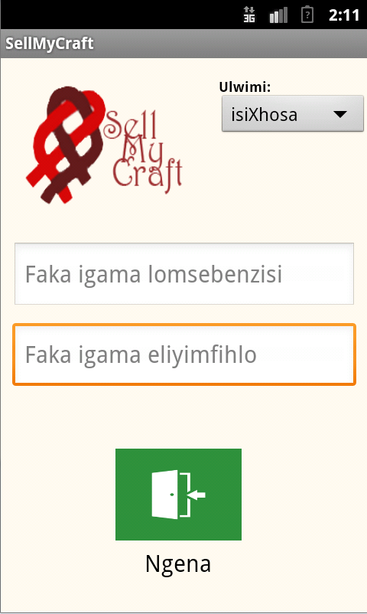 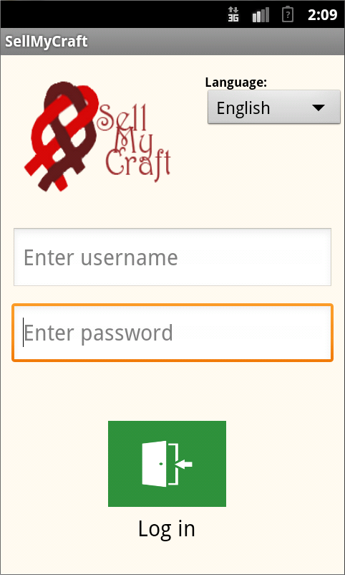

Figure 29: Mock-up (Login Screen)

Table 15: Use Case Narrative (UC02)

|  |  |
| --- | --- |
| **Use Case #** | **UC02** |
| **Use case:** | **Edit Artist Details** |
| **Purpose:** | The purpose of this use case is to allow the artists that have registered with Reed House Systems, and have installed and logged on to the mobile application successfully, the ability to manage their own user profiles. |
| **Overview:** | This use case is to ensure registered end-users of the system are able to customise their own profiles, by changing their profile picture, name or information about themselves. |
| **Actors:** | AC01: Artist |
| **Type:** | Essential |
| **Preconditions:** | The artist must have been registered with Reed House Systems and given a username and password. They must also be logged on to the application successfully. |
| **Postconditions:** | The artist has edited information in their profile either the picture, name or details about themselves, successfully. |
| **Special requirements:** | The mobile application will store information on an internal database until such a time the application is able to synchronise with the TeleWeaver database through Wi-Fi connection, which is when it will synchronise the changes with the TeleWeaver servers. |
| **Main Flow of Events** | |
| **ACTION** | **SYSTEM RESPONSE** |
| 1. The artist wishes to change information about themselves. 2. The Artist clicks on the *Edit My Info* button 3. The artist is able to change their profile picture by clicking on it 4. If *Upload picture from phone* is chosen   If *Take new picture* is chosen   1. The artist is able to change information in any of the text fields such as: *Name, Surname*, and *Information.* 2. The Artist will select the mobile’s *Back* button to submit their profile changes. | 1. Once the artist has logged on to the mobile application successfully they will be taken to the *Main Menu*.      1. The *Profile* page of the artist will open with their details from the face-to-face interaction with the Outreach Project already loaded. 2. When the profile picture is clicked on a pop-up will open asking whether the user would like to Upload a picture from their phone or Take a new picture or Cancel.   The mobile’s photo gallery will open which will allow a user to select a photo already saved on their phone as their new profile picture. Once a picture is chosen the *Profile* screen will be redisplayed with the chosen picture as the new profile picture.  The mobile application will open the phone’s camera where a new picture can be taken and selected as the artist’s new profile picture. The *Profile* screen will be redisplayed with the chosen picture as the new profile picture.   1. The information in the text fields can be edited freely by using the keypad to enter in data and change existing data. 2. The artist’s *Profile* screen will be redisplayed with the relevant changes updated on the screen |
| **Alternative Flow of Events** | |
| 1. If *Cancel* is chosen | The mobile application will return to the *Profile* page without changes being made to the profile picture. |
| **Activity Diagrams:** | None |
| **Systems Operations:** | * login(username, password) * editArtistDetails(name, surname, dOB, phoneNumber) |
| **Author:** | ITS-Africa Solutions |
| **Date created** | 21/05/2013 |
| **Date last modified:** | 11/09/2013 |
| **Modified by:** | Abram Rankapole |

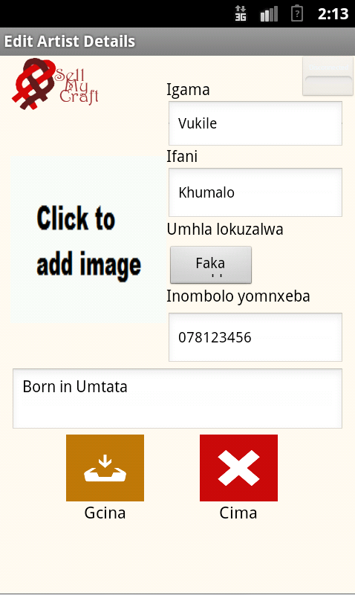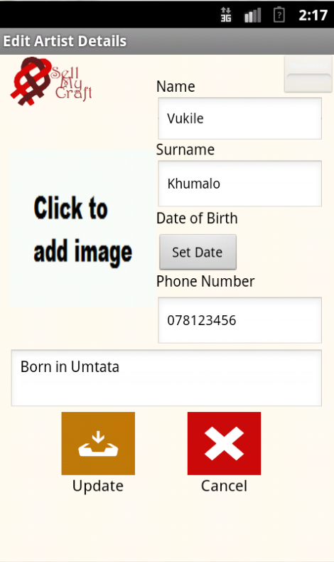  
Figure 14: Mock-up (Edit Artist Details Screen)

Table 16: Use Case Narrative (UC03)

|  |  |
| --- | --- |
| **Use Case #** | **UC03** |
| **Use case:** | **Add New Product Details** |
| **Purpose:** | The purpose of this use case is to allow the artist to add a new artwork or craft, using the mobile application, for sale on the internet. |
| **Overview:** | This use case is to allow the artist to add artwork or crafts using the mobile application onto the central database, controlled by TeleWeaver, through the internal database on the mobile application. |
| **Actors:** | AC01: Artist |
| **Type:** | Essential |
| **Preconditions:** | The artist must have been registered with the Reed House Systems and have been given a username and password. The artist should also be logged onto the system successfully. |
| **Postconditions:** | The artist has added product(s) in the form of (an) artwork(s) or craft(s) to their profile for sale on the internet. |
| **Special requirements:** | The mobile application will run on an internal database that has been developed to store product items when the main database, TeleWeaver is offline. However the databases need to be synchronised in order for the products to go on sale as sales are dealt with through the TeleWeaver database. |
| **Main Flow of Events** | |
| **ACTION** | **SYSTEM RESPONSE** |
| 1. This use case begins when an Artist wants to upload a product for sale on the internet. 2. The artist clicks on the *Add Product* button 3. The artist inputs information into the empty fields such as: *name, description, and price of the artwork* they wish to upload. 4. The artist can also add a product picture from this *New Product* screen. (This will be covered in the narrative for UC04: Manage Product Picture) 5. Once the artist has finished entering in the relevant information they click on the *Save* button | 2. The artist is logged on to the system which means the *Main Menu* is open.  4. The *New Product* window will open displaying empty fields.  8. The system will then upload the product details to the internal database and only upload them to the server when in range of a TeleCentre. |
| **Alternative Flow of Events** | |
|  | None |
| **Activity Diagrams:** | None |
| **Systems Operations:** | * addNewProductDetails(name, dimensions, price, description) * addProductPicture(name) * changeProductPicture(name) |
| **Author:** | ITS-Africa Solutions |
| **Date created** | 21/05/2013 |
| **Date last modified:** | 12/09/2013 |
| **Modified by:** | Abram Rankapole |

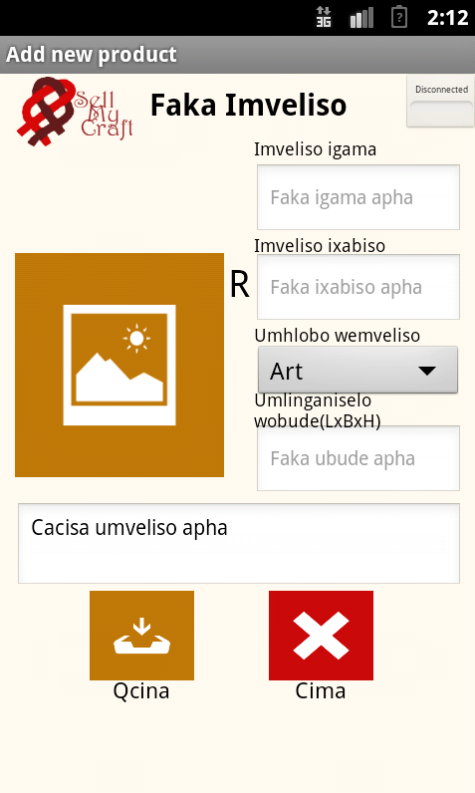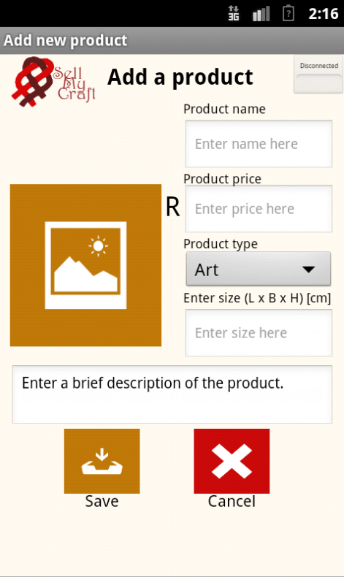

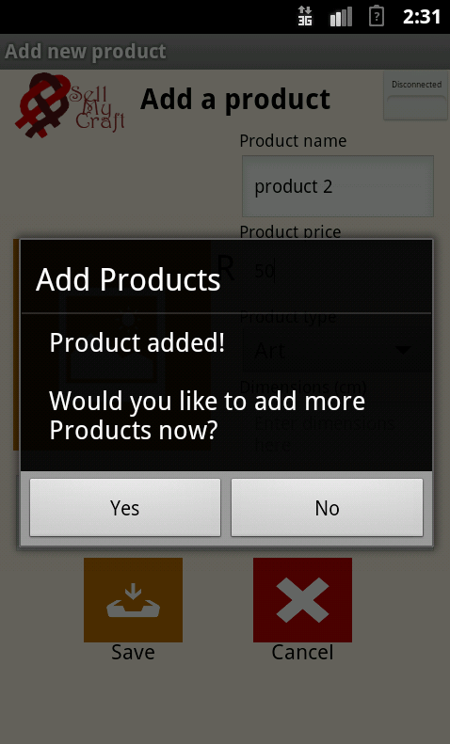

Figure 15: Mock-ups (Add New Product Details Screens)

**Table 15: Use Case Narrative (UC04)**

|  |  |
| --- | --- |
| **Use Case #** | **UC04** |
| **Use case:** | **Manage Product Picture (extends UC03: Add New Product Details)** |
| **Purpose:** | The purpose of this use case is to allow the artist to upload a picture of their artwork or crafts using the mobile application. |
| **Overview:** | This use case is to allow the artist to upload a picture of their artwork or crafts using the mobile application onto the central database, controlled by TeleWeaver, through the internal database. This will upload to TeleWeaver once they are within range of the TeleCentre. |
| **Actors:** | AC01: Artist |
| **Type:** | Essential |
| **Preconditions:** | The artist must have been registered with the Reed House Systems and have been given a username and password. The artist must also be successfully logged onto the system and be in the process of adding new product details (UC03). |
| **Postconditions:** | The artist has added product picture(s) in the form of photos of (an) artwork(s) or craft(s) to their product for sale on the internet. |
| **Special requirements:** | The mobile application will run on an internal database that has been developed to store product items when the main database, TeleWeaver is offline. However the databases needs to be synchronised in order for the products to go on sale as sales are dealt with through the TeleWeaver database. |
| **Main Flow of Events** | |
| **ACTION** | **SYSTEM RESPONSE** |
| 1. This use case begins when an artist wishes to add a product picture to their product.  3. The artist clicks on the *No images yet* picture icon   1. If *Upload picture from phone* is chosen   If *Take new picture* is chosen   1. The artist can add up to four product pictures in the same manner. 2. If *Replace an existing picture* is chosen   11. The artist clicks on the *Add Product* button on the *New Product* screen | 2. The artist is successfully logged onto the system and has the *New Product* screen open.  4. A pop-up will appear asking whether the user would like to Upload a picture from their phone or Take a new picture or Cancel.  6. The mobile’s photo gallery will open which will allow a user to select a photo already saved on their phone as their new product picture. Once a picture is chosen the *New Product* screen will be redisplayed with the chosen picture as the new product picture.  The mobile application will open the phone’s camera where a new picture can be taken and selected as the artist’s new product picture. The New *Product* screen will be redisplayed with the chosen picture as the new product picture.  8. If there are already four product pictures uploaded for one particular product, the system responds by a message asking whether the artist would like to *Replace an existing picture?* Or *Cancel.*  10. The system will show the user the four existing pictures and the user will be able to select one to replace. This will then become one of the pictures associated with that product and the *New Product* screen will be redisplayed.  12. The system will then upload the product details and picture(s) to the internal database and only upload them to the server when in range of a TeleCentre. |
| **Alternative Flow of Events** | |
| 1. If *Cancel* is chosen 2. If *Cancel* is chosen | The mobile application will return to the *New Product* page without changes being made to the product picture.  The *New Product* screen will be redisplayed with no changes to the current four pictures. |
| **Activity Diagrams:** | None |
| **Systems Operations:** | * uploadProductPicture(productID, productPictureID, name) * editProductPicture(productID, productPictureID, name) |
| **Author:** | ITS-Africa Solutions |
| **Date created** | 21/05/2013 |
| **Date last modified:** | 10/09/2013 |
| **Modified by:** | Abram Rankapole |

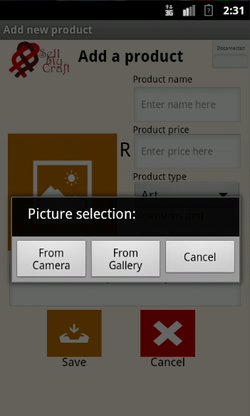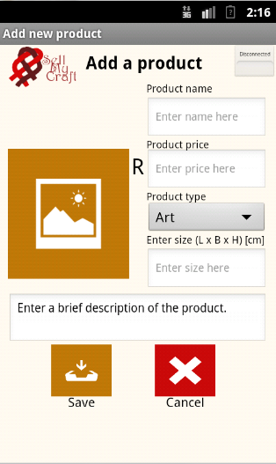  
Figure 15: Mock-up (Manage Product Picture Screen)

**Table 15: Use Case Narrative (UC05)**

|  |  |
| --- | --- |
| **Use Case #** | **UC05** |
| **Use case:** | **Manage Product Details (extends UC03: Add New Product Details)** |
| **Purpose:** | The purpose of this use case is to allow the artist to edit or delete an artwork or craft, using the mobile application. |
| **Overview:** | This use case is to allow the artist to change artwork or crafts’ details using the mobile application or delete artwork or crafts’ from the central database, controlled by TeleWeaver, through the internal database on the mobile application. |
| **Actors:** | AC01: Artist |
| **Type:** | Essential |
| **Preconditions:** | The artist must have been registered with the Reed House Systems and have been given a username and password. The artist should also be logged onto the system successfully. The artist must also have existing products on the system. |
| **Postconditions:** | The artist has changed information about (the) product(s) on their profile, or successfully removed (a) product(s) from the database. |
| **Special requirements:** | The mobile application will run on an internal database that has been developed to store product items when the main database, TeleWeaver is offline. However the databases need to be synchronised in order for the products’ information and presence to be updated on the TeleWeaver database as sales of these products are handled by the TeleWeaver. |
| **Main Flow of Events** | |
| **ACTION** | **SYSTEM RESPONSE** |
| 1. This use case begins when an Artist wants to change details about a product for sale on the internet, or delete a product. 2. The artist clicks on the *View Products* button 3. If the artist wishes to delete a product they will select the *Dustbin image* button next to the particular product they would like to delete 4. If the artist wishes to edit a product they will select the *Edit* button next to the particular product they would like to edit 5. Once the artist has finished entering in the relevant information they would like to edit, such as: “name, description, size”, the artist can click on the *Update* button | 2. The artist is logged on to the system which means the *Main Menu* is open.  4. The *View Products* window will open displaying a list of all the current inventory of the particular artist that is logged in.   1. A pop-up will ask the artist if they are sure they would like to delete the product, with the answers saying *Yes* or *No*. 2. A screen will open called *Edit Product* with the relevant information about the product that has been selected for editing.   10. The system will then upload the changed product details to the internal database and only upload them to the server when in range of a TeleCentre. |
| **Alternative Flow of Events** | |
| 1. If the artists selects *Yes*   If the artist selects *No* | The item will be deleted from the inventory and the *View Products* screen will be redisplayed with that item no longer listed.  The *View Products* screen will be redisplayed with no changes made. |
| **Activity Diagrams:** | None |
| **Systems Operations:** | * editProductDetails(artistID, name) * deleteProductDetails(artistID, name) * viewProductDetails(artistID, name, dimensions, price) |
| **Author:** | ITS-Africa Solutions |
| **Date created** | 21/05/2013 |
| **Date last modified:** | 10/09/2013 |
| **Modified by:** | Abram Rankapole |

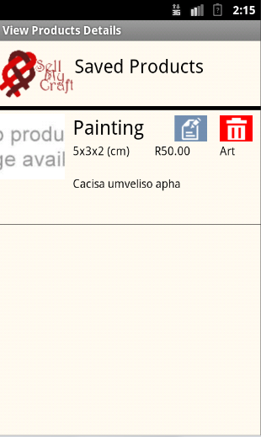

Figure 16: Mock-up (Manage Product Details Screen)

**Table 15: Use Case Narrative (UC06)**

|  |  |
| --- | --- |
| **Use Case #** | **UC06** |
| **Use case:** | **View Sales Details** |
| **Purpose:** | The purpose of this use case is to allow the artist view all sales information about their own artwork(s) or craft(s), using the mobile application. |
| **Overview:** | This use case is to allow the artist to view sales details using the mobile application. Once the application has been synchronised with the TeleWeaver server all sales information will be updated to the mobile application’s internal database. Viewing sales details allows users to see a list of their inventory in table format with columns indicating: quantity sold, quantity remaining, total revenue generated per each item, and a grand total generated. |
| **Actors:** | AC01: Artist |
| **Type:** | Essential |
| **Preconditions:** | The artist must have been registered with the Reed House Systems and have been given a username and password. The artist should also be logged onto the system successfully. The artist must also have existing products on the system, and must have recently synchronised with the main TeleWeaver database. |
| **Postconditions:** | The artist views a list of their inventory in table format with columns indicating: quantity sold, quantity remaining, total revenue generated per each item, and a grand total generated. |
| **Special requirements:** | The mobile application does not control sale of products, therefore in order to ensure sales information is up-to-date and relevant, users need to synchronise with the TeleWeaver database all the time they connect so that the information and can be updated straight onto the application and correct sales information can be generated. |
| **Main Flow of Events** | |
| **ACTION** | **SYSTEM RESPONSE** |
| 1. This use case begins when an Artist wants to view sales details about their own products for sale on the internet. 2. The artist clicks on the *View Sales* button on the Main Menu window 3. The user can then return to the Main Menu by selecting the *Main Menu* button on the *View Sales* window | 2. The artist is logged on to the system which means the *Main Menu* is open.  4. The *View Sales* window will open displaying a list of all the current inventory of the particular artist that is logged in in a table format, with columns indicating: quantity sold, quantity remaining, total revenue generated per each item, and a grand total generated.   1. The Main Menu window will open. |
| **Alternative Flow of Events** | |
|  | None |
| **Activity Diagrams:** | None |
| **Systems Operations:** | * editProductDetails(name) * deleteProductDetails(name) |
| **Author:** | ITS-Africa Solutions |
| **Date created** | 10/09/2013 |
| **Date last modified:** | 10/09/2013 |
| **Modified by:** | Giovanna Contu |

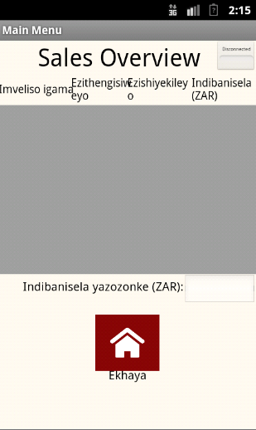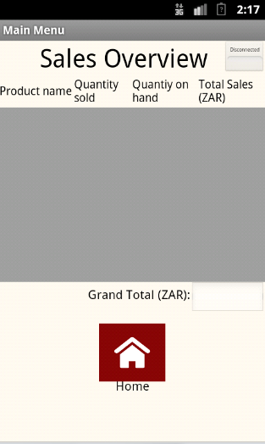  
Figure 17: Mock-up (View Sales Details Screen)

**Table 15: Use Case Narrative (UC08)**

|  |  |
| --- | --- |
| **Use Case #** | **UC08** |
| **Use case:** | **Synchronise application to TeleWeaver** |
| **Purpose:** | The purpose of this use case is to synchronise the mobile application database with the external TeleWeaver database. |
| **Overview:** | The artist needs to synchronise their data with the TeleWeaver database from time-to-time, this allows their product information to be sent in for sale on the internet, and also allows the user to retrieve accurate sales information about their products and inventory. Finally it allows any changes to the user’s profile to be updated on the TeleWeaver system. |
| **Actors:** | AC01: Artist |
| **Type:** | Essential |
| **Preconditions:** | The artist must have been registered with the Reed House Systems and have been given a username and password. The artist should also be logged onto the system successfully. The artist must also be in range of a TeleCentre access node. |
| **Postconditions:** | The artist’s data on the mobile application has been synchronised to the TeleWeaver database and any relevant information from the TeleWeaver database has been updated on the mobile application (e.g. Sales information). |
| **Special requirements:** | The mobile phone requires either a Wi-Fi or Bluetooth connection capability. The mobile application needs to be in range of a TeleCentre access node with either the Wi-Fi or Bluetooth enabled on the mobile in order to synchronise the databases. |
| **Main Flow of Events** | |
| **ACTION** | **SYSTEM RESPONSE** |
| 1. This use case begins when an Artist wants to synchronise their mobile application data with the TeleWeaver database or when the artist wants to update their data from the TeleWeaver database to their mobile application. 2. The artist is in range of a TeleCentre access node (wi-fi). 3. The artist clicks on the *Synchronise* button on the *Main Menu* window | 2. The artist is logged on to the system which means the *Main Menu* is open.   1. The icon in the top right-hand corner of the mobile application will change from a red icon indicating no connection to a green icon indicating the mobile application is connected to the TeleCentre. 2. A progress bar appears showing the updating process from the mobile application database to the TeleWeaver database. |
| **Alternative Flow of Events** | |
| 1. The artist can select the *Back* button before the synchronisation process has finished. | No updates from the mobile application database to the TeleWeaver database will occur. |
| **Activity Diagrams:** | None |
| **Systems Operations:** | None |
| **Author:** | ITS-Africa Solutions |
| **Date created** | 10/09/2013 |
| **Date last modified:** | 10/09/2013 |
| **Modified by:** | Giovanna Contu |

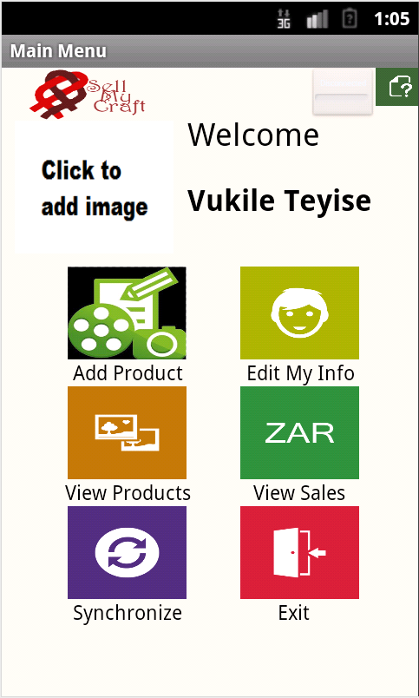

Clicked on to establish connection to Teleweaver through Wi-Fi

Figure 18: Mock-up (Synchronization Screen)

**Table 15: Use Case Narrative (UC12)**

|  |  |
| --- | --- |
| **Use Case #** | **UC012** |
| **Use case:** | **Language Translation** |
| **Purpose:** | The purpose of this use case is to change the display language of the mobile application. |
| **Overview:** | Before the artist logs into the mobile application they will be able to change the display language of the application to one which they understand from the repertoire. |
| **Actors:** | AC01: Artist |
| **Type:** | Essential |
| **Preconditions:** | The artist must have been registered with the Reed House Systems and have been given a username and password, and have successfully uploaded the application onto their mobile phone. |
| **Postconditions:** | The display language of the application has changed to the new chosen language. |
| **Special requirements:** | The user must have agreed to the Terms and Conditions accompanied by the mobile application. |
| **Main Flow of Events** | |
| **ACTION** | **SYSTEM RESPONSE** |
| 1. This use case begins on the *Login* screen when the user wants to change the display language of the mobile application.   1. The user clicks on the *language combo box*. 2. The user selects the language they wish to view the application in from the drop down list. | 1. A list will drop down indicating all the possible display languages the application is available in. 2. The application’s display language changes from the default language to the new selected language. |
| **Alternative Flow of Events** | |
|  | None |
| **Activity Diagrams:** | None |
| **Systems Operations:** | None |
| **Author:** | ITS-Africa Solutions |
| **Date created** | 10/09/2013 |
| **Date last modified:** | 10/09/2013 |
| **Modified by:** | Giovanna Contu |

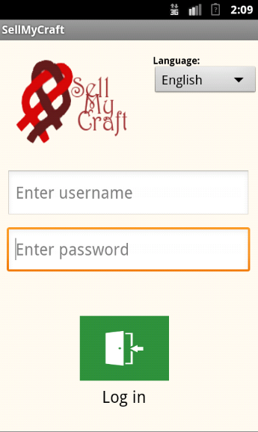

Figure 19: Mock-up (Translate language Screen)



## Design-level Class Diagram

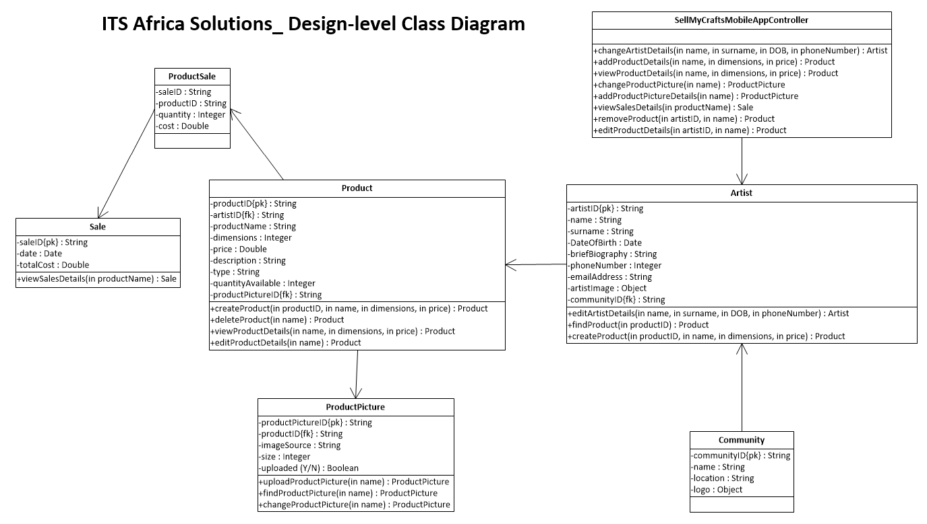

Figure 30: Design Class Diagram

## Multilayer Sequence Diagrams

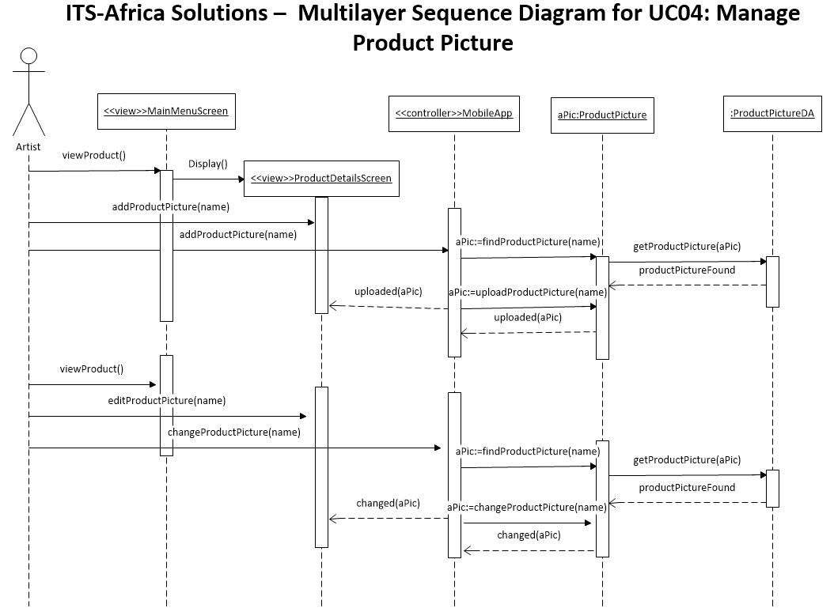

Figure 31: Multilayer Sequence Diagram for Manage Product Picture (Iteration 2)

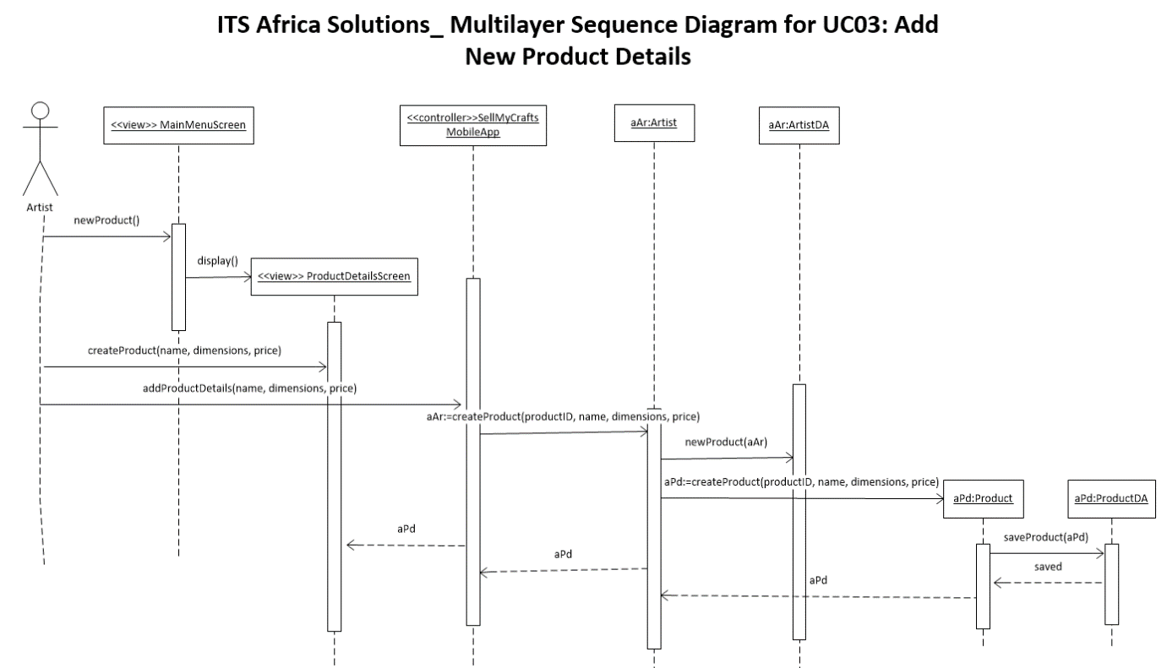

Figure 32: Multilayer Sequence Diagram for Add New Product Details (Iteration 2)



Figure 33: Multilayer Sequence Diagram for Manage Product Details (Iteration 2)

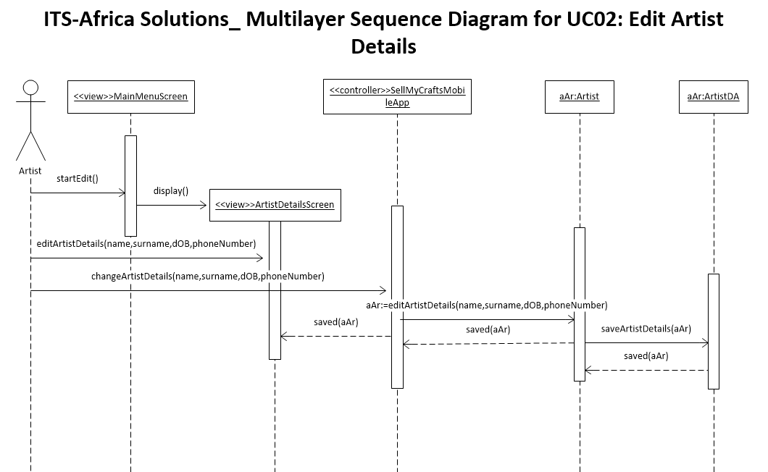

Figure 34: Multilayer Sequence Diagram for Edit Artist Details (from Iteration 1 & 3)

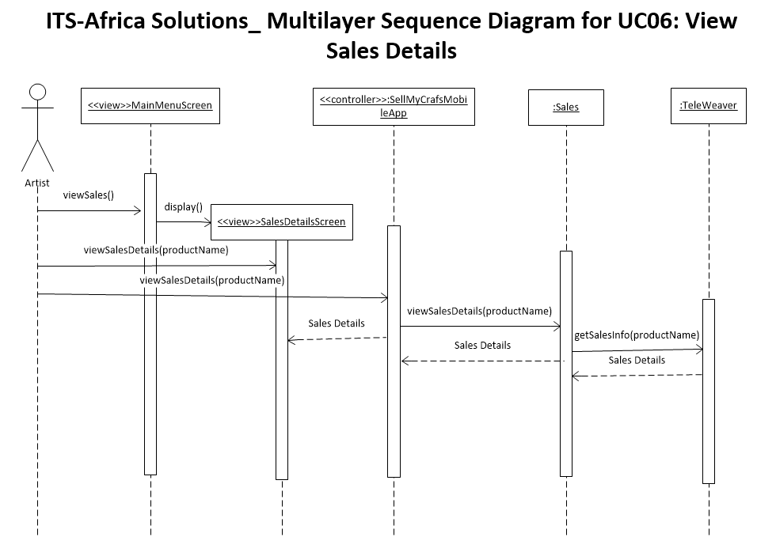

Figure 35: Multilayer Sequence Diagram for View Sales Details (from Iteration 3)

## Package Diagram

Figure 36: Package Diagram

# Appendices

## Glossary

**Context diagram** - a data flow diagram, with only one massive central process that subsumes everything inside the scope of the system. It shows how the system will consume inputs and export outputs to external entities involved.

**Class diagram** - defines the classes in a system by illustrating object-oriented programming features such as class relationships, operations and attributes.

**Wares** - artworks, crafts and any items wished to be sold on the e-commerce site.

**TeleWeave**r - a packaged “integrated enabler for rural TeleCentre and access nodes” (Reed House Systems 2011). It is adaptable and custom built to account for the limited resources of rural areas and works with a mobile middleware technology OSGI.

**Joint Application Development** - methodology that involves the client or end user in the design and development of an application, through a succession of collaborative workshop (Rouse, 2007).

**Unified Modelling Language** - the standard notation for describing and modelling object-oriented systems (Stumpf and Lavette, 2005).

**E-Commerce -** the industry that exists by conducting the buying and selling of products or services over an electronic system for example: the Internet or other online networks.

**Open Services Gateway Initiative -** “The Open Services Gateway Initiative is a consortium of more than 80 companies from around the world working together to create an infrastructure to enable the deployment of services over wide area networks to local networks and devices.” (Marples and Kriens 2001) It is a light, compliant technology that runs on Java-enabled phones. (Reed House Systems 2011).

## Acronyms

Table 17: Acronyms

|  |  |
| --- | --- |
| **UC** | Use Case |
| **E-Commerce** | Electronic Commerce. |
| **OSGI** | Open Services Gateway Initiative. |
| **UML** | Unified Modelling Language |
| **JAD** | Joint Application Development. |
| **AC** | Actors |